Radar and Sonar

Ranging techniques such as radar and sonar solve two main problems: determining the presence or absence of a target and estimating parameters of interest such as range and speed. Active methods transmit a known waveform and receive a distorted echo while passive methods listen only. In the simple case of a single pointlike target and colocated receiver and transmitter, e.g. monostatic configuration, systems such as radar and sonar are desgined to measure the range and range rate of a target. A waveform is transmitted, distorted in some fashion upon incidence on the target, and matched filtered receiver. The presence of a target is indicated by a peak in the receiver response. The height of the peak is related to detection and its breath to parameter resolution. Since distance is related to time by the speed of the wave and the narrowness of the response peak localizes the target in time, good range resolution requires a narrow pulse or large signal bandwidth. As for the speed, the phase of a transmitted waveform changes by 2pi for every half wavelength of one way range change resulting from a moving target,

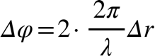

Therefore detecting the phase can be used to measure the speed of a target. Lower wavelength or higher frequency/long pulse duration governs range rate resoltuion. Thus there is an inherent trade-off between time and frequency on the quality of the range and range rate measurements. Indeed as we will see range and range-rate cannot simultaneously be measured with arbitrary precision. This problem is addressed by modulating a low bandwitdh amplitude function onto a carrier to facilitate both transmission through the desired media and also to improve resolution.

The problem of localizing a target position in space, e.g. angular direction, handled by the antenna and is treated in the chapter on array processing. Z = (r,v,theta)

The subject of this chapter is how to design, detection, and target parameter estimation for active waveforms. In the simplest case, only a single target and Gaussian noise is present at the receiver. In general, multiple targest must be resolved in the presense of interference resulting additional sources or reflections.

Wideband vs narrowband.
Clutter vs. self-clutter.

In the first part, signal model, parameter resolution and waveforms are discussed. In the second part optimum receivers for parameter estimation are derived and simulated.

Narrowband Signal Model for Constant Range Rate

Here we consider only the monostatic case where RX and TX are collocated and can be syncronized by a local oscillator. For now only a single reflection is considered, thus h(t) = delta(t-tau)

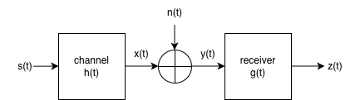

The baseband unit engery signal s(t) with complex envelope or amplitude p(t) and phase modulation phi(t) is based through the channel h(t) and match filtered at the receiver to produce the output z(t). For now we consider only white Gaussian noise n(t) thermal noise from the receiver electronics. In general the received signal is also parameterized by unknown spatial variable representing the direction of arrival (DOA), however, this will be postponed until chapter 18. Input is

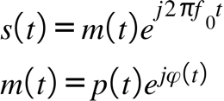

The envelope with bandwidth B<<f0 is slowly variying compared to the carrier expeonential. Neglecting the return amplitude and noise for now, the received waveform at time t is

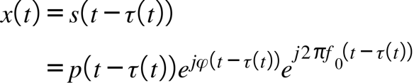

where the round trip delay is generally a function of time if the target is moving while the signal is reflecting. When the target’s radial speed (or higher order motion derivatives) is large its motion during the pulse epoch will cause distortions in the received signal. In order to quantify this distortion on the received waveform, consider a target moving with constant speed whose radial position is described by

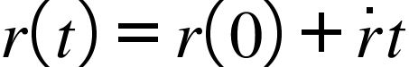

A signal received at time t was transmitted at time t-tau, and was incident on the target at time t-tau/2 when its position was

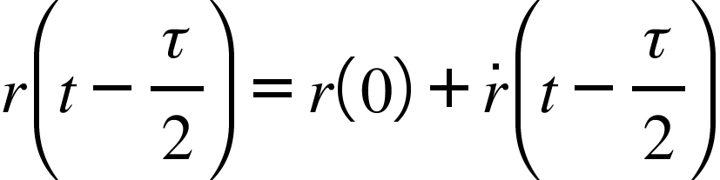

where r(0) is the position of the target when the point t=0 on the transmitted waveform is reflected. Equating the target distance () with the wave travel distance leads to an expression

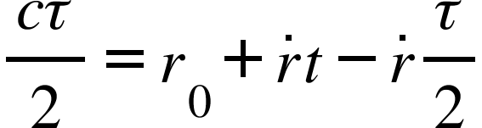

Which can be solved for tau to yield

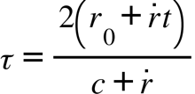

Defining the Doppler stretch factor,

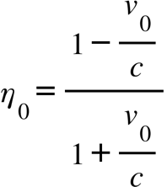

the delay at t=0

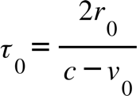

and substituting () into () leads to the most general form of the received waveform

 | 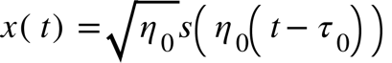 | (17-1)

which has no approximations beyond the model. Eq () is also expressed in the literature as
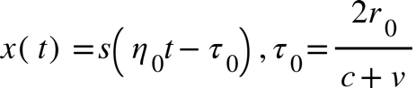

The time axis dilation causes a speed dependent energy change (increase upon approach, and decrease upon recession) which is accounted for in () by the coefficient in front. Indeed, if s(t) has unit energy, conservation of energy requires

$$\int_{-∞}^{∞}{{\left|x(t)\right|}^{2}dt=η}\int_{-∞}^{∞}{{\left|s(ηt)\right|}^{2}}dt=1$$

For moving targets in general, the received waveform will be compressed for approaching objects, and dilated for receeding. In the first case, more noise will enter during reception interval [0,T], and in the second the fully energy will not be accumulated, both resulting in a decrease in snr.

A minor simplification of () can be achieved by expanding () under the assumption 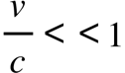, which leads to

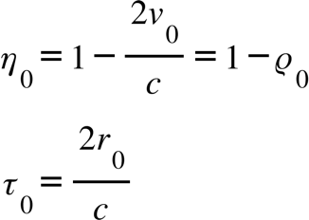

In avionic radar applications where v/c < 10-3 the approximation is quite sound. In aquatic sonar where v/c < 1/10, it is less so, and for sonar in air v/c ~ 1/3 it is not valid.

Apart from a constant phase shift, the effects of constant velcotiy motion on the received signal

are a compression or dialation of the envelope and a shift in the carrier frequency.

Ideally, a simple matched filter receiver, e.g. something like an FFT bank, would estimate the time delay from shifted envelope replicas and the motion parameters from the carrier phase. Under a signal model such as () this is not possible. Let us therefore investigate the conditions under which the envelope distortion can be approximated by a simple delay shift. Expanding the real amplitude (and phase) in a Taylor series

enables bounding the rate of change by the bandwidth B with the largest deviation ocurring at t=T. Therefore if the dispersion product

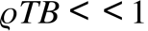

the higher order terms may be neglected and the envelope distortion can be approximated by a constant delay in what is known as the narrowband approximation. Eq () can be used, together with system parameters to establish the maximum target speed for which the approximation holds. For example, underwater channels are more constrained in their TB product given that the speed of sound several orders of magnitude less than the speed of light. Furthermore, the assumption of constant velocity breaks down when the change in velocity is on the order of the velocity. Employing () we can bound this requirement as

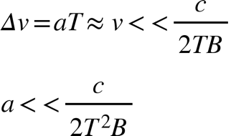

What remains is to account for the delay time variation in the carrier phase term which is more motion sensitive than the envelope by about the factor 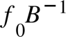. Substituting the simplified expresstion for tau(t) into () yields

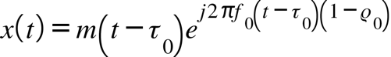

Which is simply the delayed transmitted signal with a Doppler shifted carrier frequency

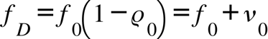

For positive range rate (receeding target) the carrier is shifted lower and conversely for negative range rate approaching targets. Range will be overestimated in the envelope due to unaccounted for higher order derivatives.

For matched filter reception, the impulse response of the receiver will be the time reversed complex conjugate of (). The unknown Doppler motion parameter is estimated from a multidimensional filter bank each tuned to a specific Doppler shift. The maximum response at the output of the filter bank provides an estimate of target motion. Again we see that in the narrowband regime delay time is estimated from the envelope and motion from the RF phase.

Eq () can then be used to form a Dopler shifted template

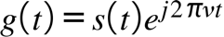

for the received signal and the ML values for delay and Doppler can be determined by maximizing the MF output

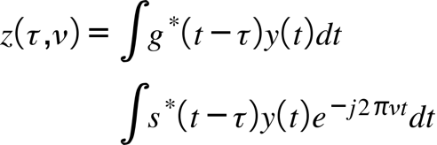

over delay and Doppler space. After sampling, Eq () is amenable to efficient computation via an FFT.

Narrowband Signal Model for General Motion

Delay is in general a complicated function of time that may change over the pulse duration, especially for long pulse lengths and high target speed. For short enough time periods, i.e. intervals of time on the order of signal processing switching, the target range, range-rate, and round trip delay are smooth functions of time, i.e. the don’t change very much, and thus the delay may be expanded in a Taylor series. The series expansion introduces the target paramteters of range, range-rate, range acceleration, jerk, and so forth, so that the radar measurement can be interpreted as a determination of target range in its derivatives.

Since the delay depends on the target position at the instant of signal reflection, which for a signal received at time t occurs at time 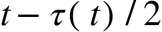, where 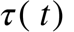is the round trip delay function, the delay of a return arriving at time depends on the target range as

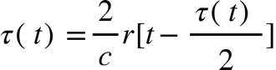

The function r(t) gives the range to the target at time t, and thus is a radial distance. Expanding the delay in a series about an arbitrary point on the waveformduring reflection gives

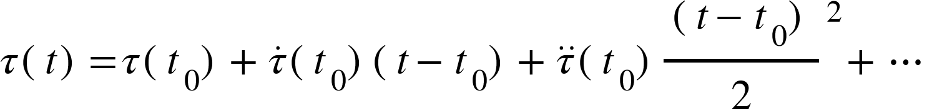

We choose as the reference the point on the waveform t=0 being received and define the roundtrip delay tau0=t0.

so that

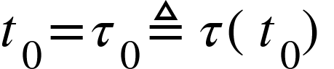
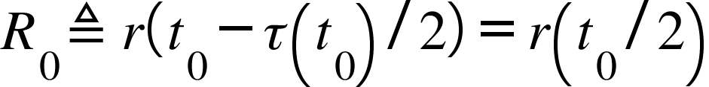

thus t0 and R0 are the round trip delay and range of the target corresponding to the trailing edge of the waveform, respectively. All range derivatives are similarly taken at half the rountrip delay time. With more suitable coefficients () becomes

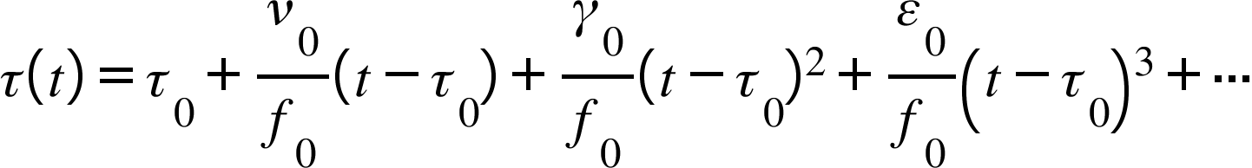

where
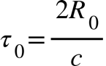
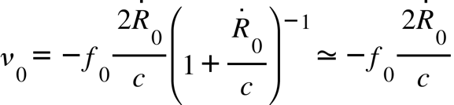
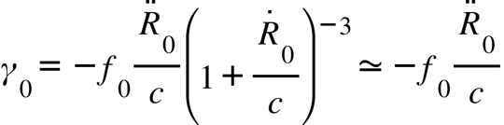

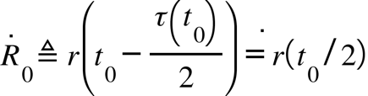
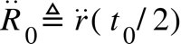

For example, the Doppler shift coefficient () is computed from

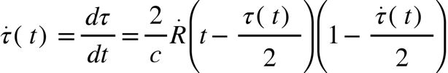

which results in () after solving for 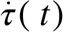and substituting in ()-(). Note that 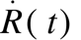represents the range rate of the target and thus Doppler shift is only affected by velocity components along the radial line between souce and receiver. We will often use abbreviation 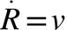where it is understood that v is the radial velocity.

Under the narrowband approximation the received signal is a progressively higher order sum of phases weighted by the appropriate range derivative coefficient (f0=0th, v0 = 1st, etc

The parameterized replica for matched filtering is

As the receiver parameters are varied, the matched filter output

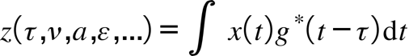

will reach its maximum value at 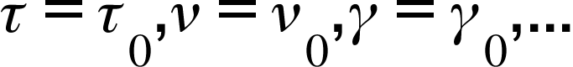 . Substituting () into () we see that the output becomes a complicated function of the rf phase

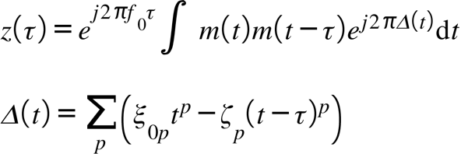

where we have defined

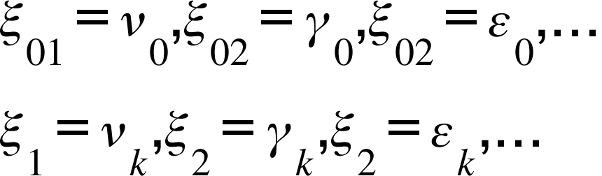.

Parameter coupling occurs when higher order motion effects contaminate the filter outputs for lower order motion estimation. For example, a quadratic phase signal or an accelerating target both impart a linear term which couples with the Doppler estimation. To see this explicitly define the differential or mismatch parameters and expand the polynomials in (), then collecting terms and leads to and expression for the phase up to 3rd order motion

where we have ignored constant phase terms because they effect all matched filter outputs the same and thus do not disturb the relative location of the peak. In () the higher order range derivatives produce an ambiguity in both the Doppler and acceleration measurements. The coefficients of the powers of t describe an uncertainty surface which impairs the accuracy of the desired parameter. Any parameter combination which produces the same value will be indistinguishable at the receiver output. However, if the range is known a priori, for example by a very short pulse, the differential delay can be set to zero and the coupling is eliminated. It is of interest to evaluate this case for independent parameters becaues it enables us to calculate the inherent or limiting precsion of the system. Selecting the half power width as the criterion for resolution, we can compute this extent, or bin width, for each of the pth order motion parameters. Two targets separated by the bin width are considered resolvable. We do this for the simple case of a rectangular pulse as the results are similar for more complex signals. Setting all terms to zero in () except the mismach parameter 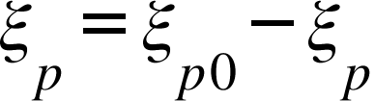 of interest yields a set of integrals

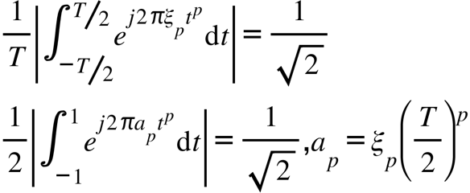

which can be evaluated numerically to find the 3dB point. The integrals are plotted in Figure () and the values are listed in Table ()

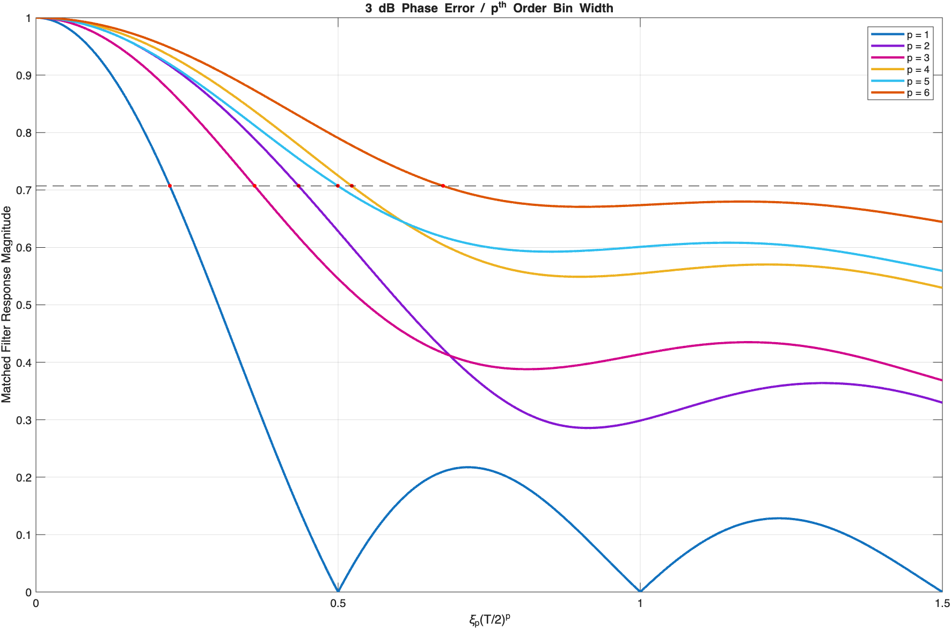

p | 1 | 2 | 3 | 4 | 5 | 6
ξ_{p}(T/2)^{p} | 0.2215 | 0.4345 | 0.3618 | 0.5223 | 0.4996 | 0.6736

Interestingly, in Table () the phase values are relatively constant for all types of motion. The prior analysis can be used to determine the minimum separation between two targets which can be resolved,e.g. the close target nominal resolution. Using 1/2 as a reasonable approximation for 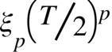 implies that at the edge of the waveform a pi phase shift corresponds to a 3dB reduction in the filter response. Equivalently, since the phase shift of a moving target is (factor of two from roundtrip)

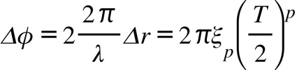

a range change of less than a quarter wavelength will cause two targets to fall in the same bin. Using one half wavelength over the signal interval T as a criterion for close target resolvability, the limiting range change can be used to bound the motion parameters. Based on the distance travelled the minimim separability for speed and acceleration are

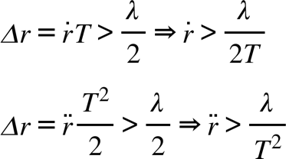

Ambiguity Functions

In a system where parameters are measured by peak filter response, performance depends on how localized the response is in the desired parameter space. The more concetrated the filter output, the better a system can distinguish between two targets with different parameters. Though its form is similar to a matched filter, the interpretation of the ambiguity function is to evaluate the receiver response for mismatches in range, Doppler, etc than what was intended. For instance, the intent of the AF is to evaluate discriminatory capability for say, two targets at and 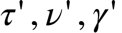.

The ambiguity function is the special name given to the signal only component of the matched filter. It is used to characterize resolution, inform on signal design, and evaluate performance in both single and multi-target scenarios. The most general form is the so called wideband ambiguity function which incorporates the envelope distortion arising from high speed targets. Beginning with (17-1), the matched filter signal only output correlates the received waveform with a parameterized replica

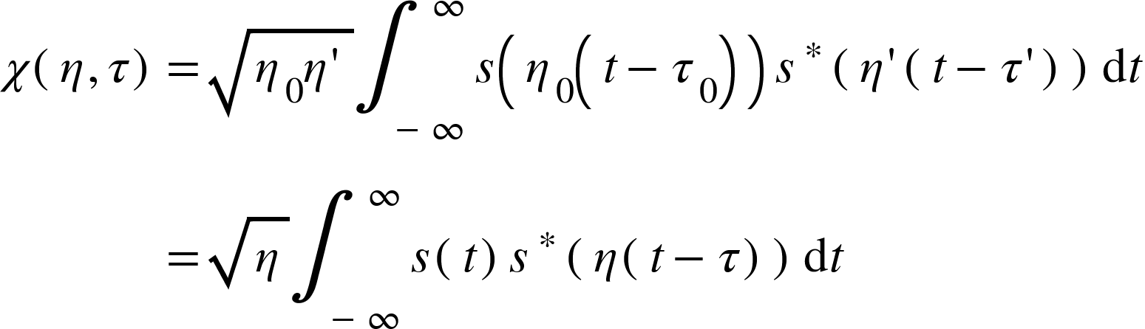

with mismatch parameters 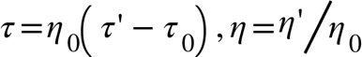. Other formulations are possible with different definitions of the mismatch parameters and/or using only the magnitude.

The narrowband ambiguity function ignores envelope distortion and therefore correlates the transmitted signal with only a time and frequency shifed replica

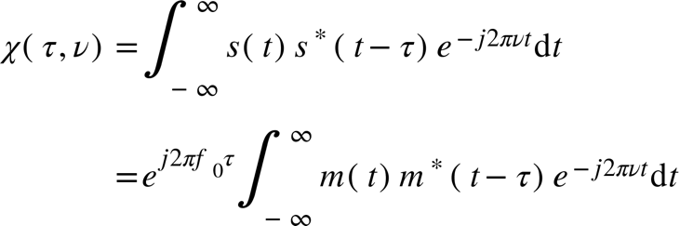

or in angular Doppler shift

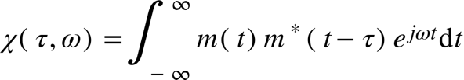

The phase term can typically be ignored since f0tau (f0 large) is close to integer and/or the optimal detector requires only the magnitude response. Using the Fourier power thereom and time and frquency shifting properties, () is equivalently expresed as

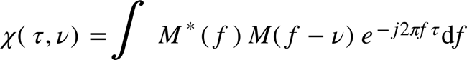

With these two simple expressions radar resolution theory becomes simple, but with the addition of each range derivative more unwieldy.

A relationship between the wide and narrowband ambiguity functions can be obtained by expanding () in a Taylor series

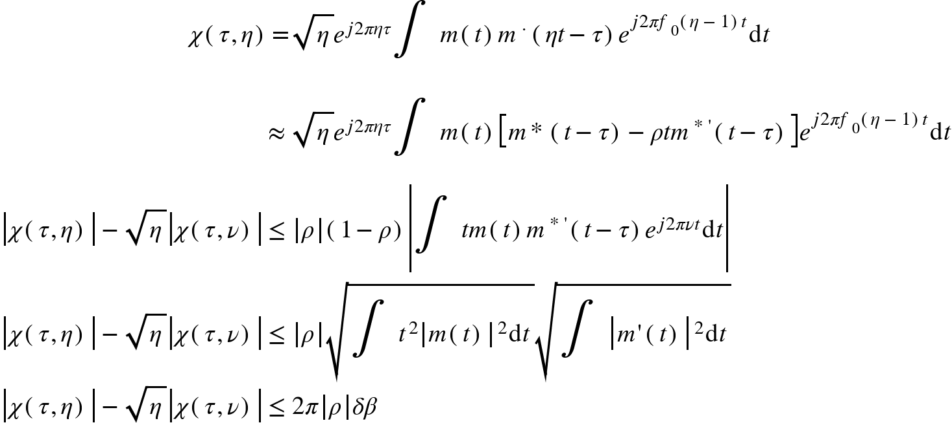

where we have used the triangle and Cauchy Scwartz inequalities for functions, and the Fourier relationships from Section (). Again we see the dispersion product representing the bound for determining the wide and narrow regimes.

The envelope of the AF defines a surface, thus we often refer to abs(X) as the ambiguity surface.

Properties and Constraints

All waveforms unit energy.

abs(X(t,v) <= X(0,0) = 1. Cauchy schwartz

Symmetries

Conservation of Volume
The NAF is constrained to be its own Fourier transform.
Constant Volume - If you decrease volume in one place, it will appear elsewhere.

Shearing

m(t)exp(jkt^2) with m(t) having X(t,v) goes to exp(tau^2jpik)X(t,v+ktau)

Uncertainty Ellipse

doit with a cosine or Gaussian.

Resolution

single parameter, combined range/doppler

Waveforms

Single Rectangular Pulse

The baseband signal is a rectangular pulse of duration .

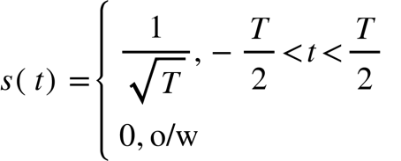

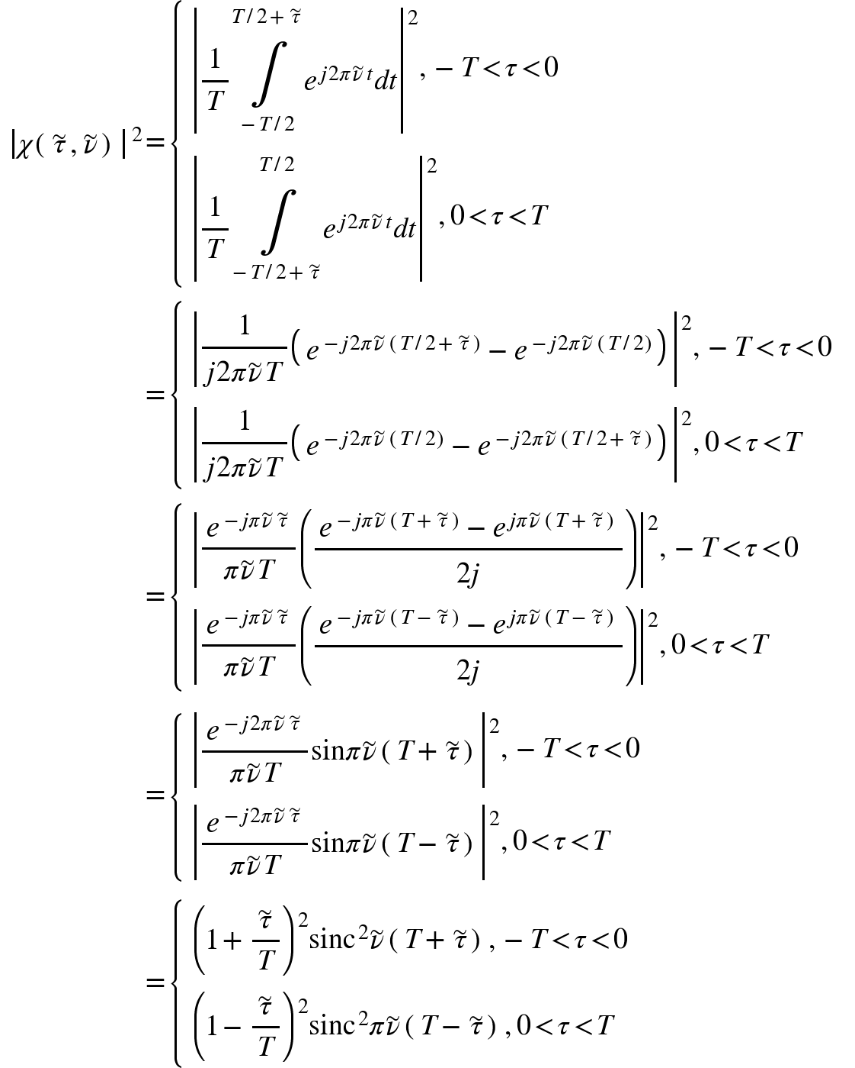

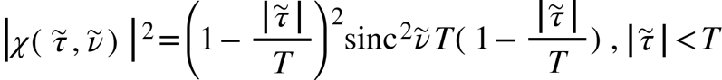

Eq () is often plotted in terms of vT and tau/T. The width of the mainlobe along the delay axis is determined by setting the Doppler coordinate to zero in () from which we obtain

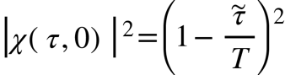

Thus the zero Doppler delay profile is triangular in shape with slope inversely proportional to the signaling epoch. Thus we expect that for shorter pulses the width of the delay profile will be smaller and hence range resolution improved.

The width corresponding to the half power height is found by solving

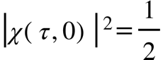

with the result

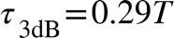

The Doppler profile for zero delay is given by a sinc function

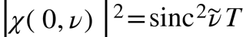

thus we expect a narrower mainlobe corresponding to longer pulses. Similarly the half power Doppler width is determined to be

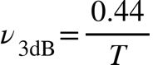

where we have used 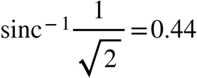. From this simple analysis it is readily apparent that one cannot have simultaneous delay and Doppler resolution for simple pulses. In the sequel we will analyze waveforms incorporating additional parameters which provide more flexibility.

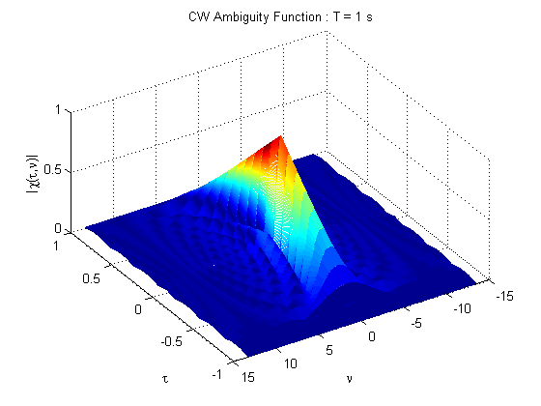
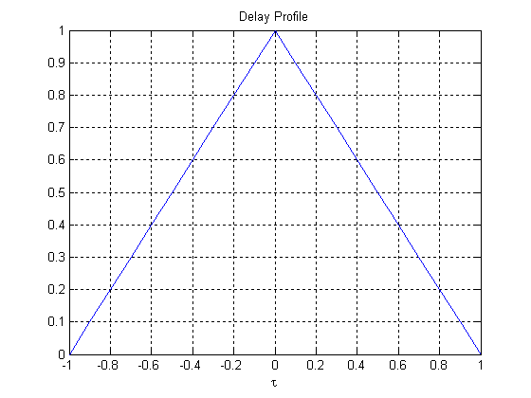

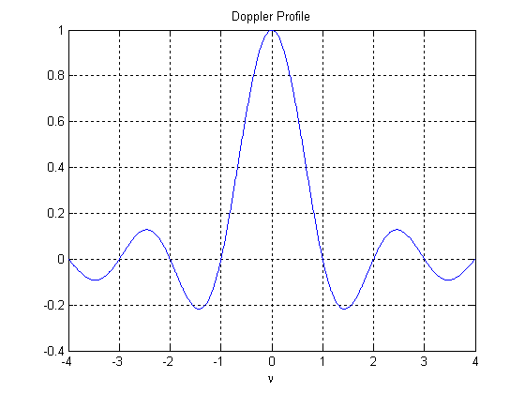

The time-bandwidth product of a pulsed sinewave is on the order of the bandwidth times the pulse width or 1/T * T =1. This implies a simple waveform lacking the degrees of freedom to independently control time and frequency resolution.

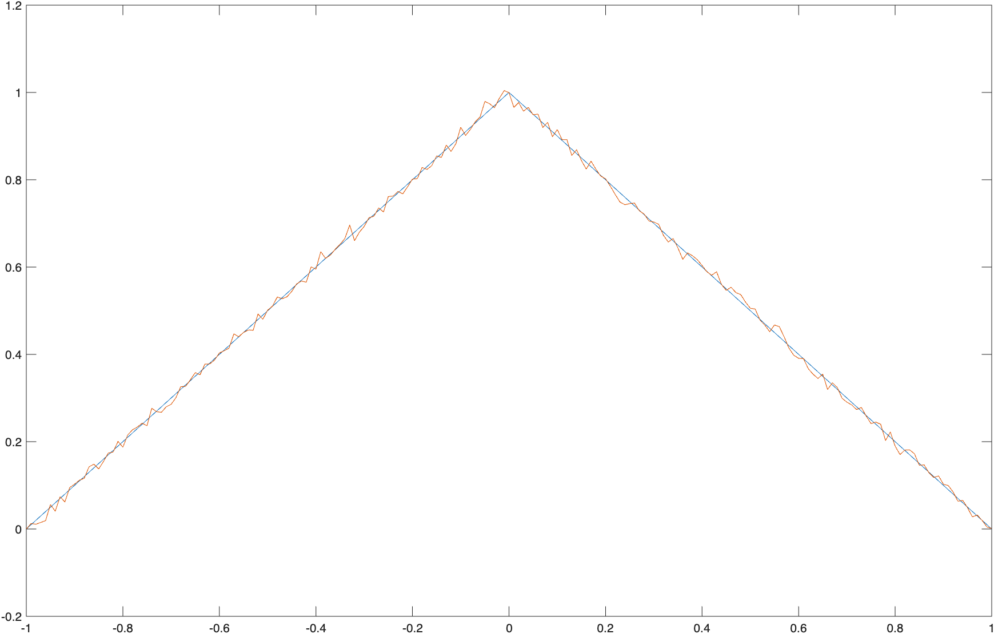

Gaussian Pulse

The Gaussian pulse is a useful analytical toy becasue many complicated expressions have closed form solutions. The unit energy Gaussian pulse with time parameter T

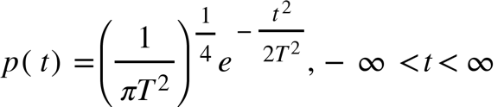

has an NAF

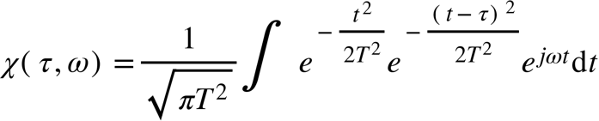

Completing the square in the exponent, applying the integral identity (), and simplifing leads to

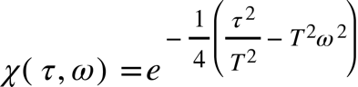

Constant contours of () define an ellipse with axies lengths proportional to T and 1/T for tau and omega, respectively. When one axis becomes small, the other is correspondingly large, thus simultaneous range and speed measurements are again not possible. In the sequel, let us explore waveforms described by more than one parameter to see if any progress can be made toward uniformly low resolution.

Coherent Pulse Trains

A unit energy signal with complex envelope m0(t) is coherently repeated in the sense that the carrier phase is continuous from one segment to the next. The complex envelope of this pulse train can be written as

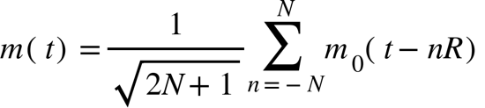

where the number of pulses is 2N+1 and the repitition interval is R. For now, we consider the case where the duty cycle

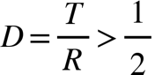

ensuring no overlap between multiple pulses for any shift.

To calculate the ambiguity function for such a signal we write

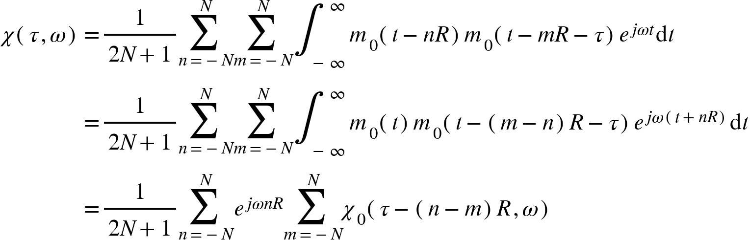

We will simplify this expression in steps. First consider the case where 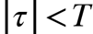. Then the shift is within a single repetition interval, n=m, and each pulse correlates with itself. Using the trigonmetric representatin for the geometric series out front leads to

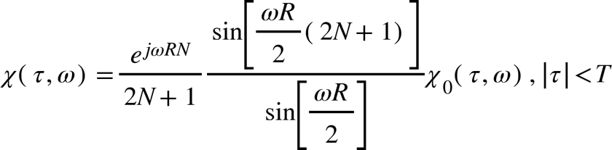

The discrete time sinc function is periodic in omega with zeros at multiples of 1/R

When tau>R-T, individual waveforms are shifted into their neighbors such that pairwise correlations between the nth and mth pulses occur. The number of such cross-correlations decrease by one with each shift of R as the support of the shifted pulse trains is reduced. It makes since to consider terms with fixed shifts p=n-m and determine the corresponding phases for each term.

Take the case N=2 with 5 pulses as an example. For p = 1 there are four (n,m) combinations: (0,-1),(1,0), (-1,-2), and (2,1) which will contribute to the sum. Terms for p=2,3,4 are

.

After 4 shifts there is no more overlap of any individual pusles. The terms for p<0 are sign reversed in phase. The phase sums are

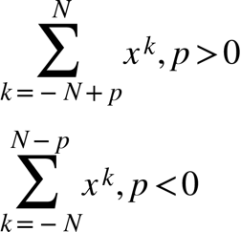

which can be combined into the normalized Dirichlet kernel 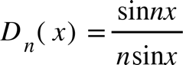 as

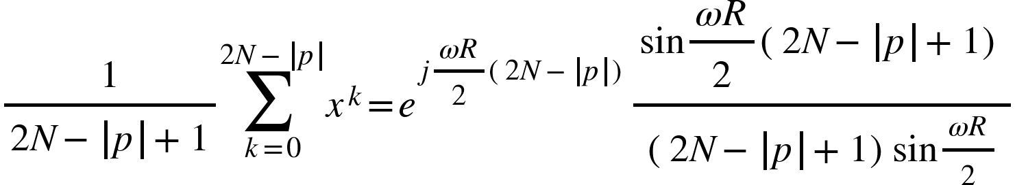

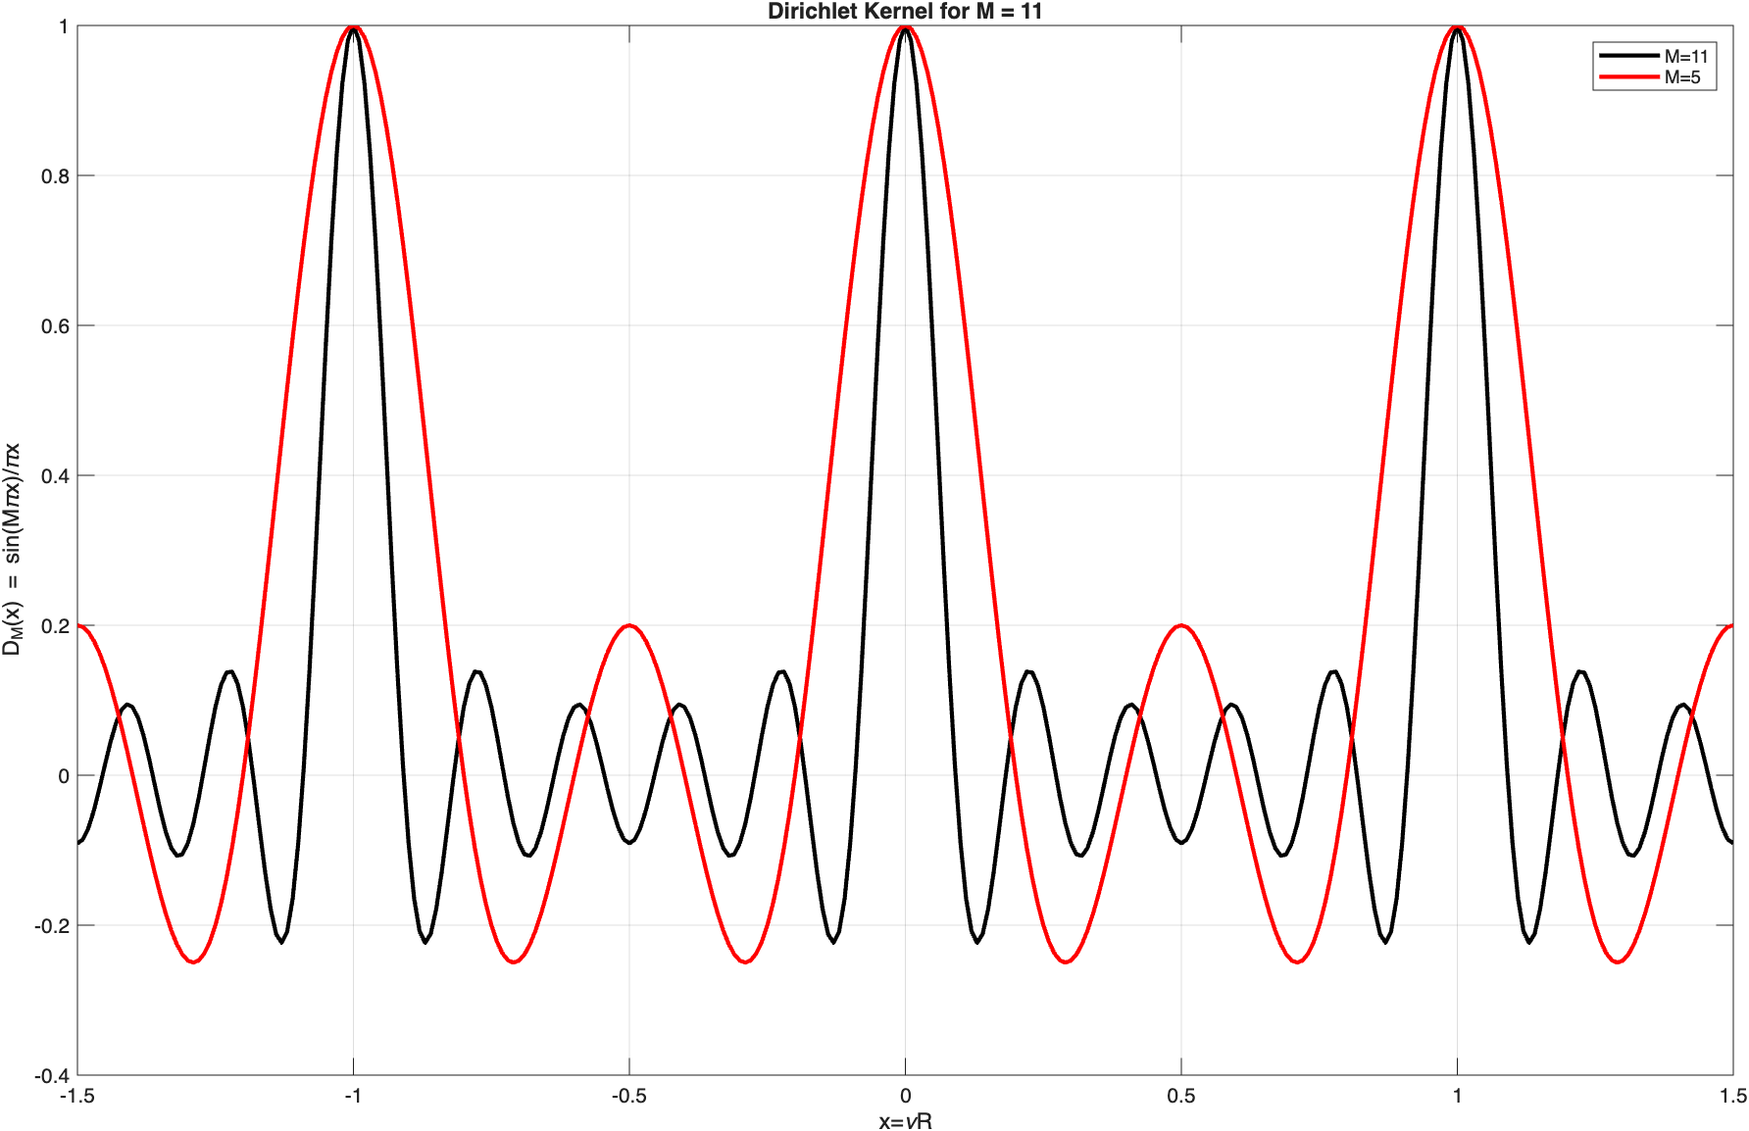Subsitituting () into () we find the ambiguity expression for a low duty cycle pulse train

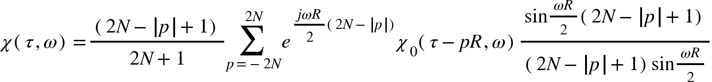

Minor simiplifications can be made by taking the magnitude, switching to linear frequency (or redfining the periodic sinc), and letting M = 2N+1, leading to

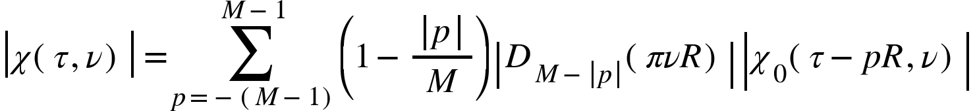

The expression in () is elegant and simple. Some discussion is in order for the special case of rectangular pulses as the theory is analogous for other waveform types. X0 is shifted on the delay axis by multiples of R and since it has support only on -T to T with duty cycle less than one-half those regions are non-interacting. For each of these shifted regions the periodic frequency amplitude samples the response vertically along the frequency axis to fill the Doppler region at a given R multiple of delay. The triangular amplitudes in p and tau linearly decrease the response away from the origin.

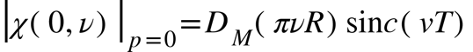

The second sinc function is wider than the first by the factor MR/T and thus the first interoplates the second at intervals of the period 1/R. The extent of the mainlobe is dominated by the periodic component with width inversely proportionanal to the signal length 1/(M*R). Therefore it is possible to improve the Doppler resolution independently of the pulse duration T by either increasing the repitition interval or number of pulses.

In the delay domain the matched response is identical to the single pulse case

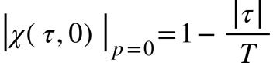

with mainlobe width on the delay axis proportional to T.

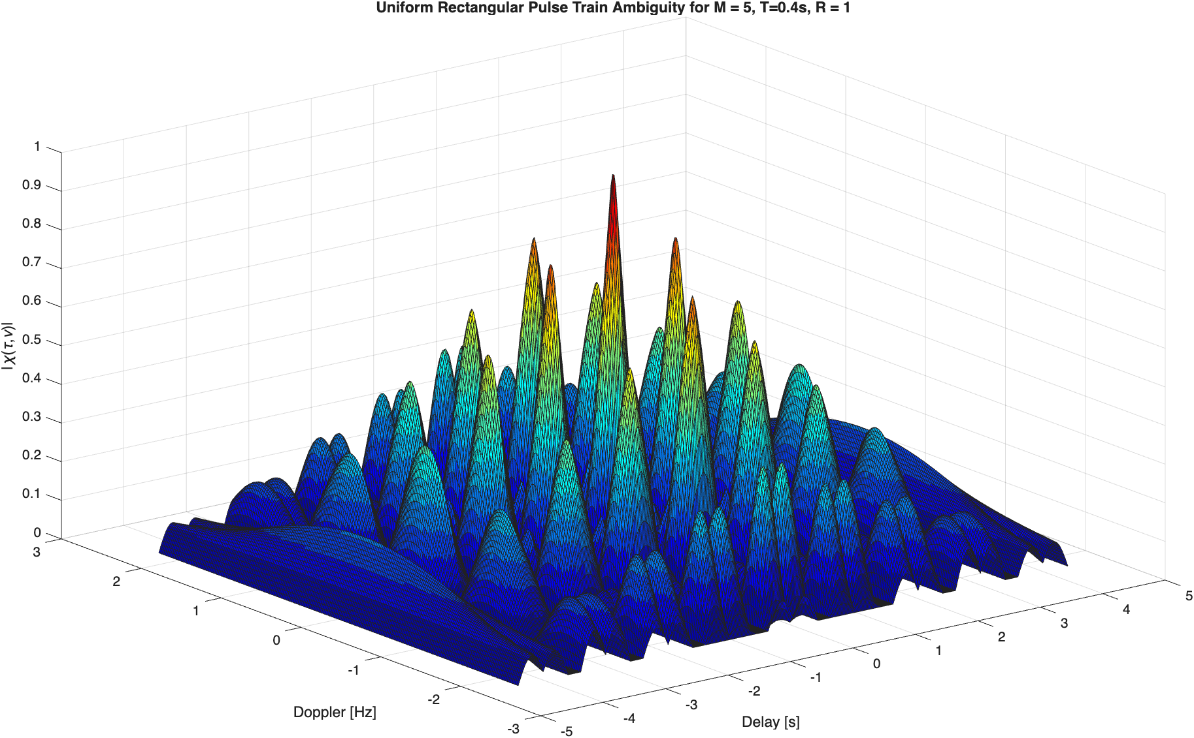

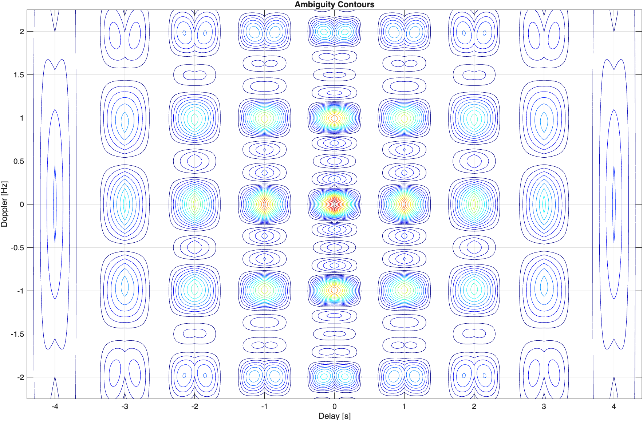

The penalty for the improved decoupling of range and range-rate resolution is the formation of subsidiary peaks. While the inherent or single peak Doppler resolution has improved, the secondary peaks effect the global or close target separability because depending on the noise larger errors can occur from mistaken peaks. In this sense, this type of error could be interpreted as a type of self clutter. If the expected range-Doppler target area is within the vicinity of the primary response, 1/R for Doppler and 2T for range, self-clutter can be ignored.

The reapportioning of ambiguity volume makes sense because the volume must remain consant. All the volume removed from the center lobe reappearing in adjacent spurious features comprising the self-clutter.

Phase Modulation

The ideal ambiguity function would have all target energy compacted in a single narrow spike and zero elsewhere. Obviously, this is not feasible, so perhaps a narrow spike of some width protruding from a flat pedestal region is possible. The goal of signal design in general and pulse compression in particle seeks to approximate such a distribution of ambiguity volume.

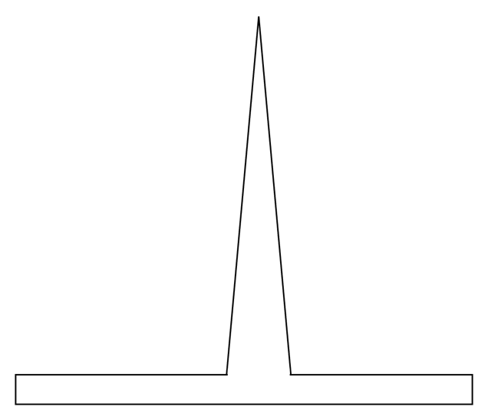

A typical narrowband system employs the amplitude envelope for range estimation. The width of the matched filter response peak determines range resolution which is inversely proportional to the bandwidth. Therefore, to increase bandwidth, without decreasing the pulse length requires phase modulation to compress the output into a narrowspike without adversely decreasing the energy on target or reducing the Doppler resolution.

From section () we know that rms bandwidth can be increased by adding nonlinear phase modulation. The nonlinear phase simultaneously increases the rms signal duration. We also know that the time bandwidth product (section ()) has a lower bound of ½. Pulse compression signals are those with a large time-bandwidth product. Pulse compression is used to increase the bandwidth without decreasing the pulse duration.

From section (), the rms bandwidth is

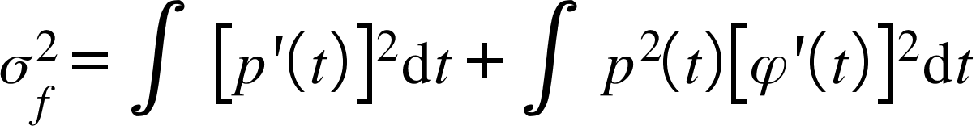

Thus any nonlinear phase modulation provides additional bandwidth relative to the frequency spread generated by the real amplitude. Since the increase in bandwidth is independent of the pulse duration phase modulations provides the flexibilty to improve delay resolution without reducing SNR.

Linear Frequency Modulation

A common choice of phase is

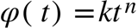

Interestingly, gravity waves emitted from colliding black holes are described by (). On earth, for n=1 we have quadratic phase modulation or linear frequency modulation (LFM). The key aspect of LFM waveforms is the symmetry between frequency and time.

A general LFM pulse is given by

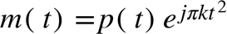

where the sweep rate is

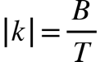

For positive k the frequency increases from f0-B/2 to f0+B/2 over -T/2 to T/2 and decreases from f0+B/2 to f0-B/2 for negative slope. From () the instantaneous baseband frequency is

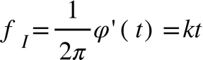

and from () the group delay can be obtained by the inverse function of () as

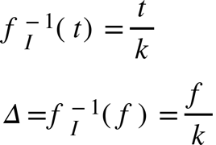

Note that dividing by k preserves the correct units.

Using the stationary phase approximation (_) for large TB waveforms the spectrum is roughly

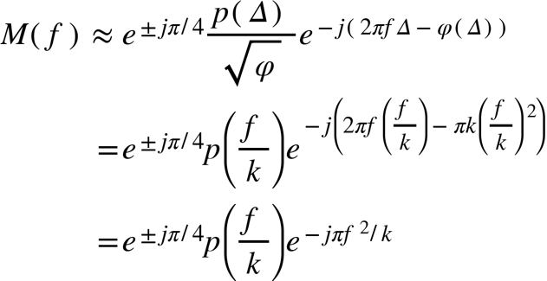

The sign of pi/4 is determined by k. The spectrum is also phase quadratic with t replaced by f/k and the amplitude compressed by k.

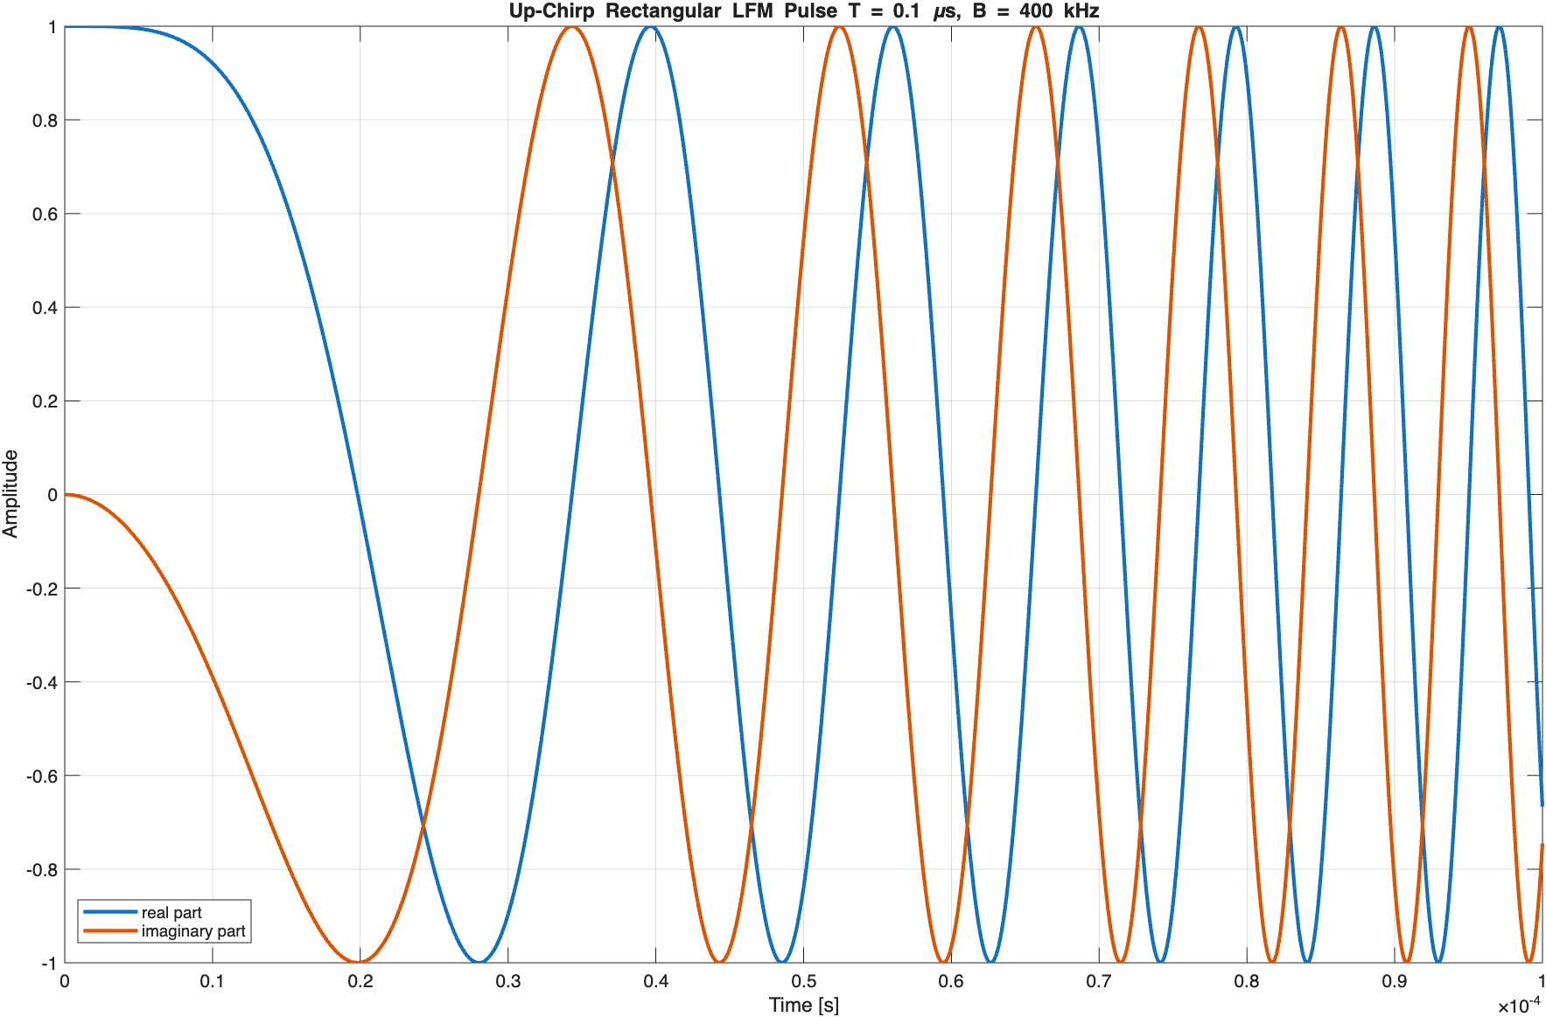
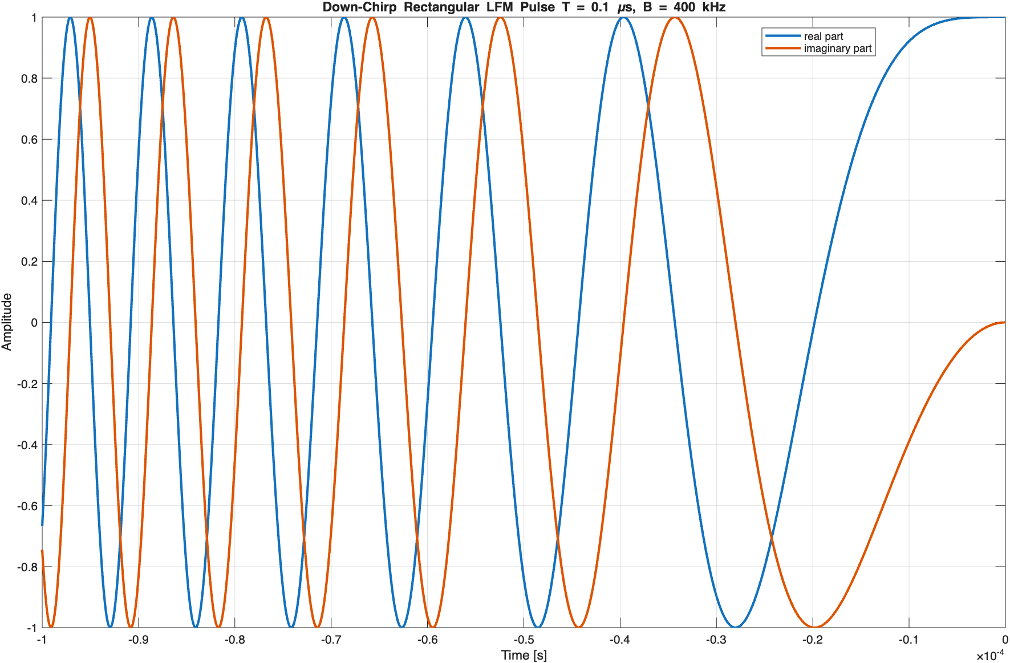
From a matched filter perspective, the time-frequency symmetry in LFM functions manifests as an interchaneability between delay and Doppler translations. Because the group delay is a linear function of frequency, a spectrum shift is equivalent to a delay shift:

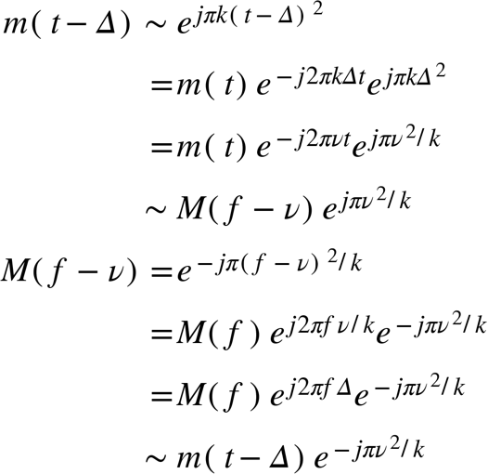

The affect at the receiver is Doppler shifts can offset mismatches in timing and conversely delay shifted waveforms are sensitive to Doppler. A Doppler mismatch shifts the time response in delay, and a delay mismatch translates the center frequency of the spectrum response. Therefore a bank of Doppler filters is not required to process a moving target. If for example, the range is known, the Doppler estimate is the peak of the response spectrum.

For only LFM, the coupling is maximized, as seen in Figure (). A doppler and delay shifted replica is nearly completely overlapped with the transmitted signal.

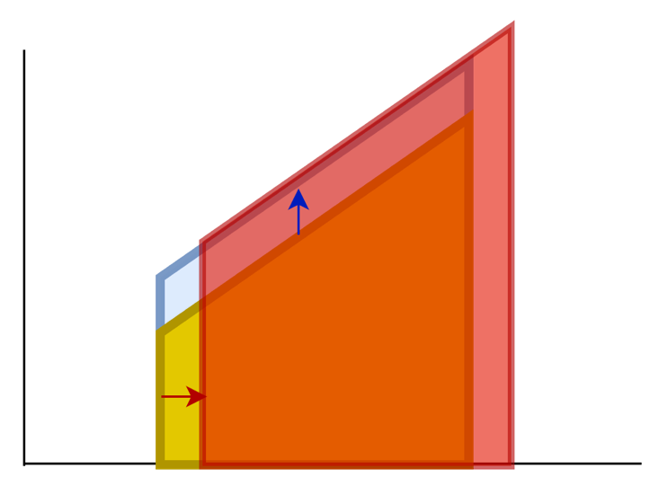

A receiver with a transfer function matched to the transmitted waveform has a quadratic phase response. The group delay is the derivative which is -f/k. For this response, low frequencies which occur at the beginning are delayed more than high frequencies at the end which results in a mainlobe output duration extend which is smaller than the input. This is called pulse compression. For an input of T seconds, the output mainlobe width is reduced to approximately 1/B or a factor about equal to the time-bandwidth product, TB, smaller.

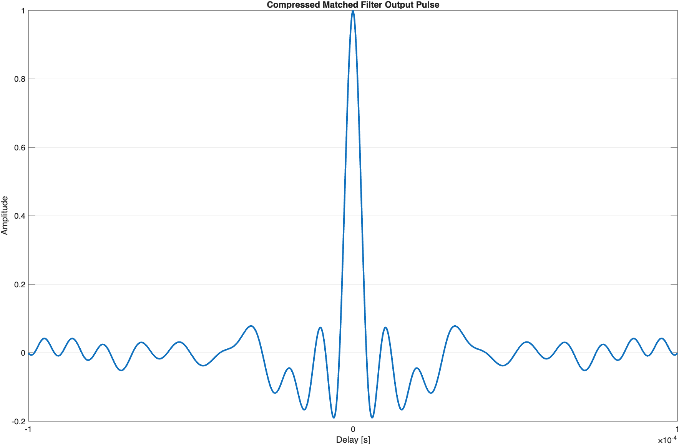

In Figure () the orignal pulse width of 0.1 us is reduced at the matched filter output (z=xcorr(real(s))) to 2*0.1/(B*T) = 0.005 um. An additional effect of the compression is to increase the power as seen in Figure ()

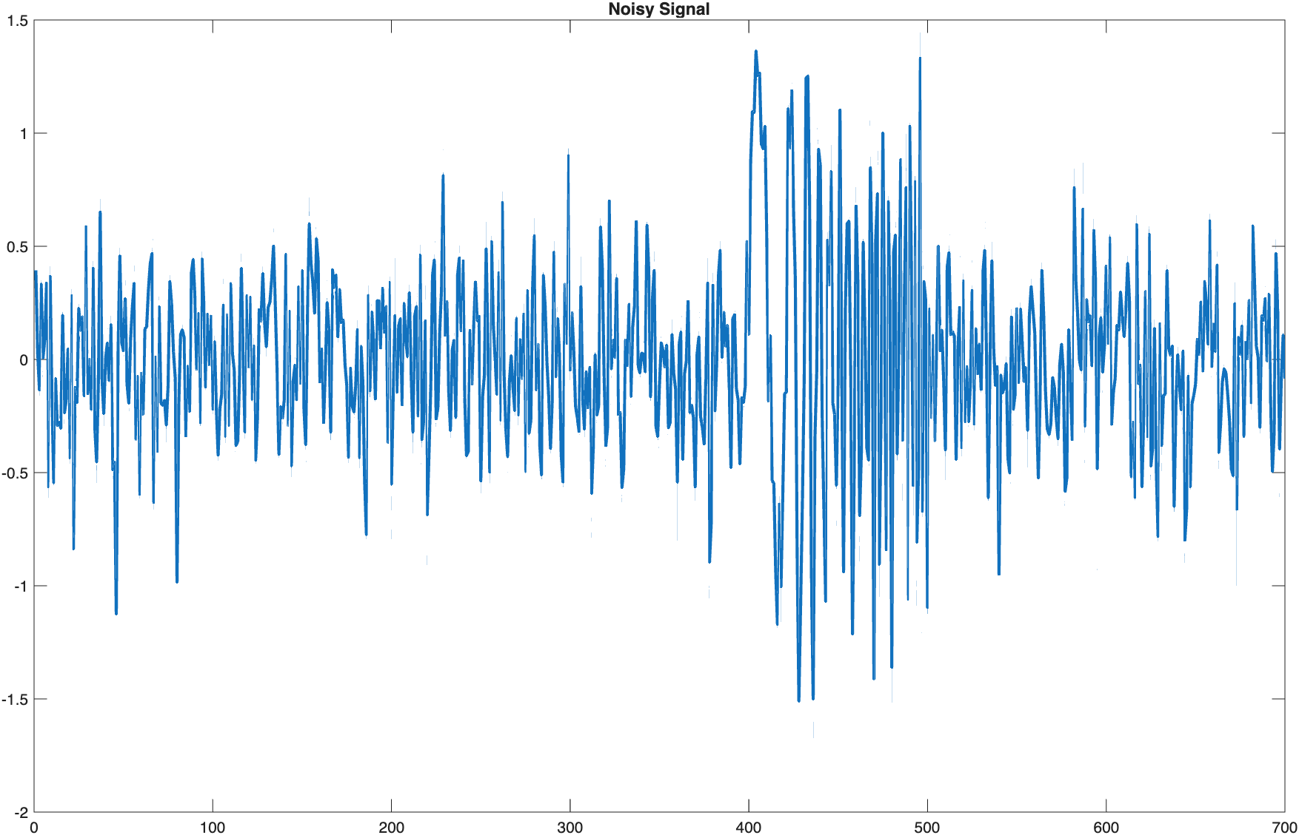
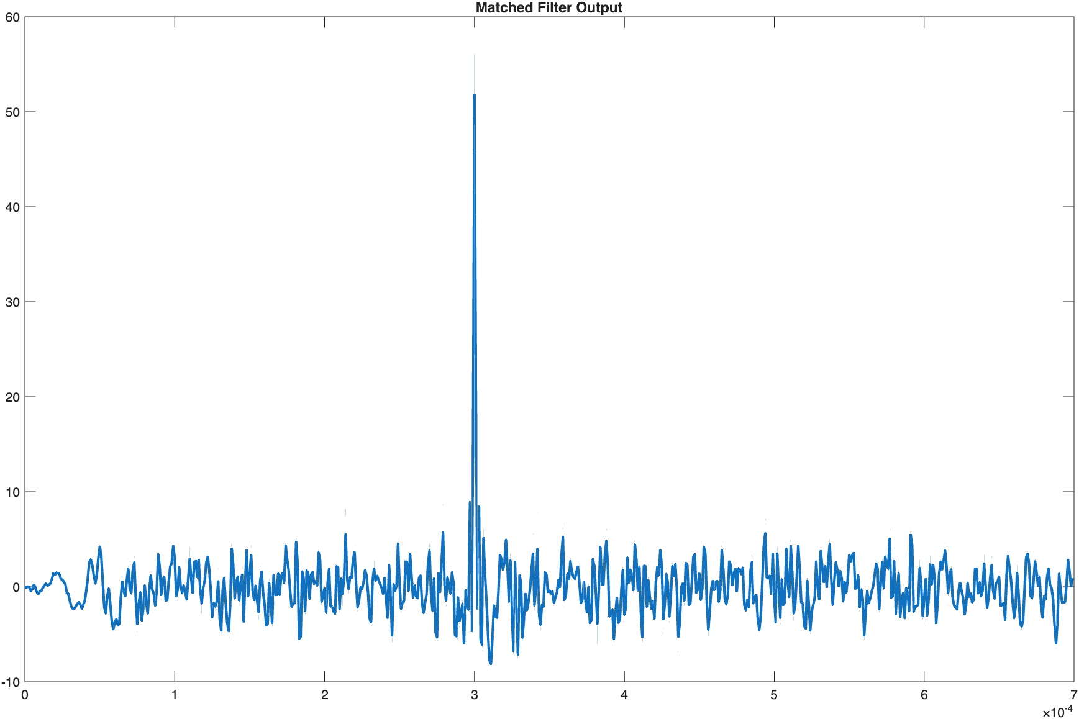

The ambiguity function for 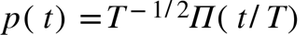and $\begin{matrix}0 & ≤ & τ≤T\end{matrix}$is

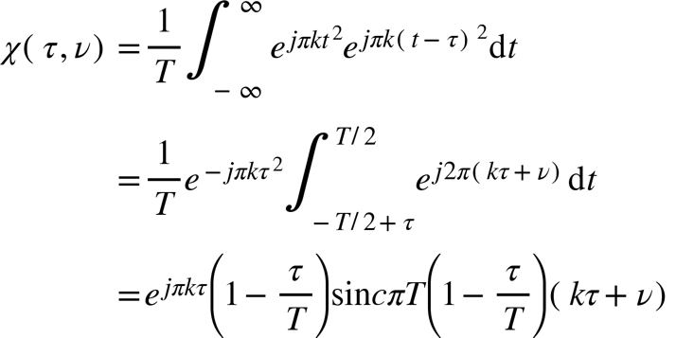

Using 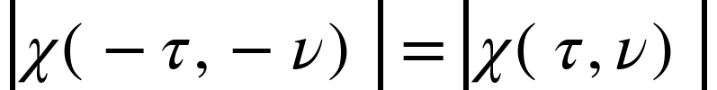 and the eveness of sinc(x) we find

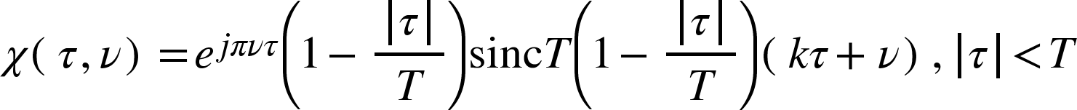

The expression () can be plotted as a function of TB for x=tau/T and y=vT.

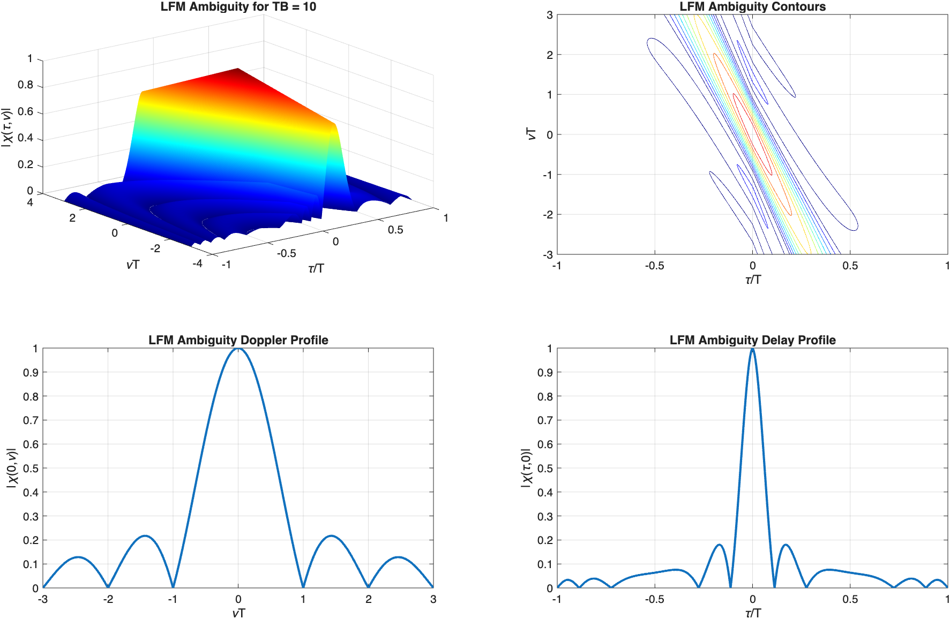

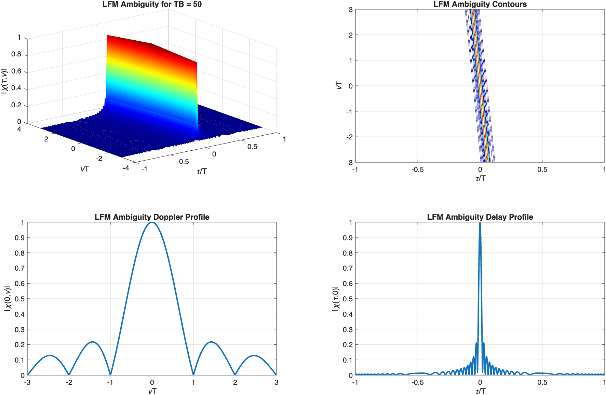

The elongated ridge corresponding to the line ktau +v =0 is an expression of the coupling between range and range rate. Any combination of v=v0 and tau = -v0/k, or tau=tau0 and v=-ktau are indistinguishable. As the TB increases, the subsidiary ridges become concentrated in the main spine.

The triangular amplitude represents the finite signal duration and the partial overlap between the shifted rectangular envelopes. For values of tau~=0, the signal duration is reduced to T-abs(tau) which reduces the output amplitude and simultaneously increases the Doppler response width. The Doppler profile is a pure sinc function, however due to the triangular aperture residing within the sinc, the delay profile is nonlinearly distorted sinc functinon. The zero doppler delay resolution corresponding to the mainlobe found when

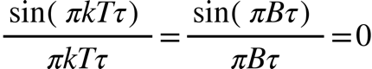

which occurs for . Similarly, the zero delay doppler resolution is v=1/T. Therefore, in LFM increasing the bandwidth allows improved delay resolution without reducing T, albeit at the expense of range-doppler coupling.

From () the spectrum should be approximatley rectangular with a phase approaching pi/4 as TB increase. The Fourier transform of () is

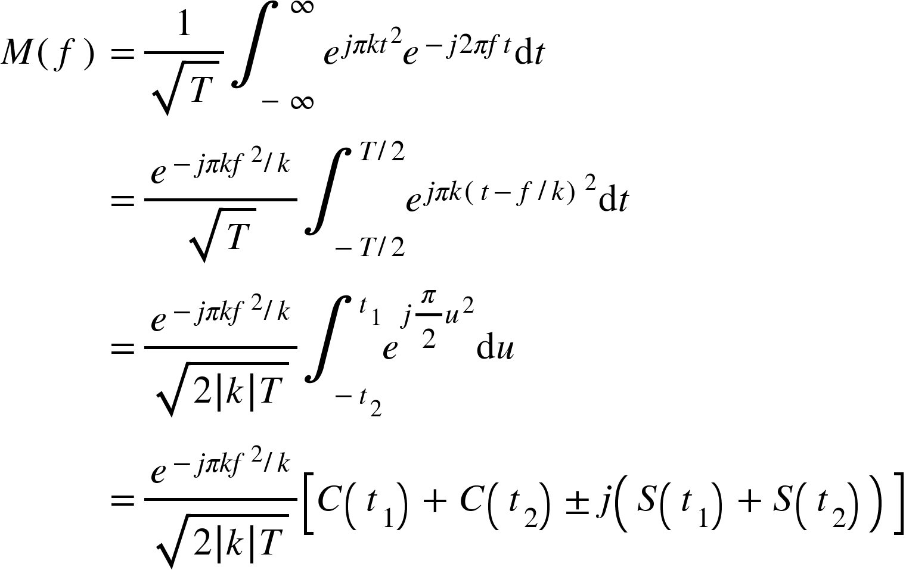

where the integration limits are

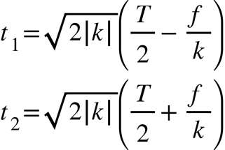

and we have used the definition and symmetry properties of the Fresnel integrals from section (). The sign in the integral is selected according to the sign of k.

Figure () plots the magitude of (),

for positive k and increasing TB illustrating the convergence toward a rectangular spectrum especially for TB>10.

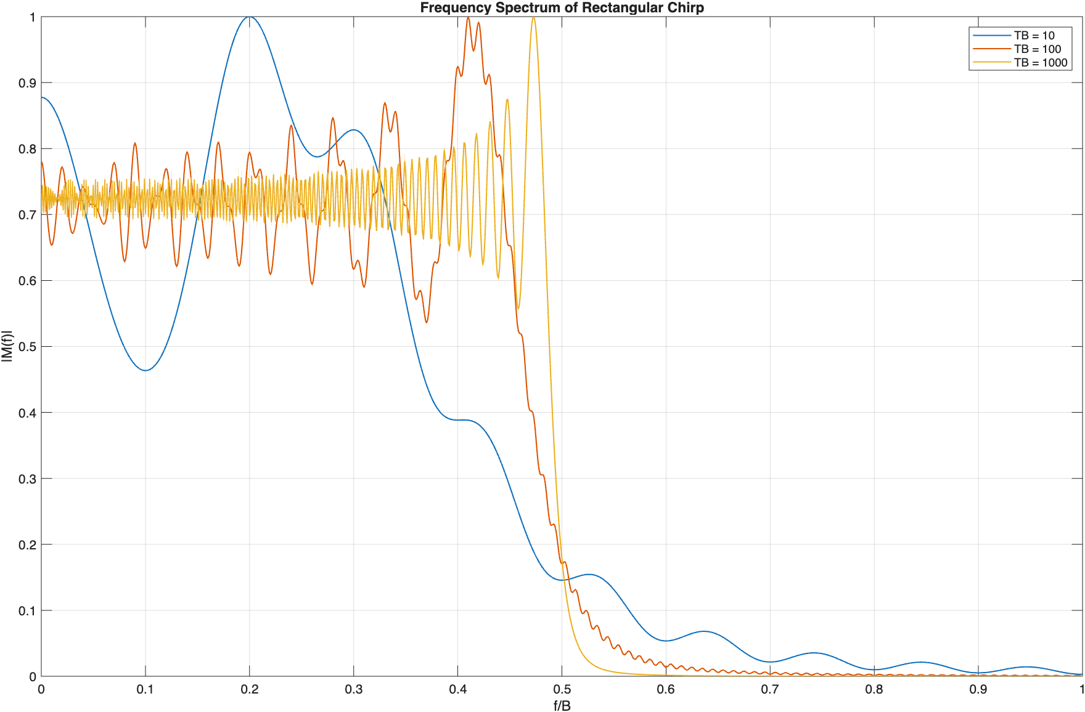

Polynomial Freqency Modulation

Hyperbolic Frequency Modulation

Coded Modulation
Costas FSK, binary

Reverberation Q-Function

Large bandwidth waveforms have a reduced temporal extent which decreases cross sectional scattering. The Richman Q-function measures this property.

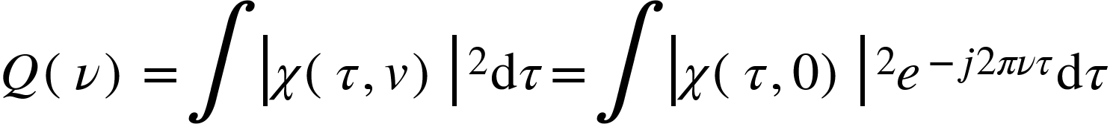

The Q-function is cumulative power over delay for a given frequency, or equivalently the power spectral density of the AF. Reverberation is typically zero Doppler so any waveform which does not have a peak at v=0 will supress stationary interference. In Figure (), for LFM waveforms, as the TB increases, the effective pulse duration decreases which reduces reverberation.

For CW q0 = 1./(2*(pi*v).^3*T^2).*(v*pi*T-.5*sin(2*pi*v*T));

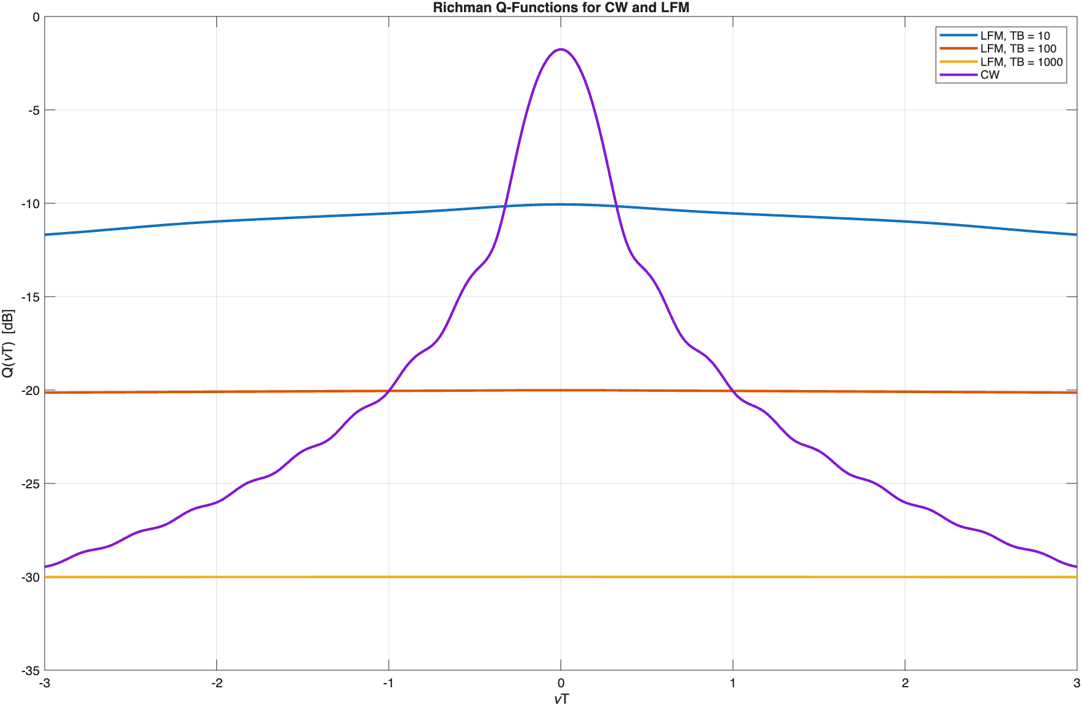

CRLB for Local Accuracy

Local accuracy or close target separation or nominal resolution refers to the fact that a target can be resolved from another target if it falls into a different resolution cell or bin. For single parameter resolution, the cell corresponds to the half power width of the central lobe of the matched filter response in that parameter. For multiple simultaneous parameters, the resolution cell is the multidimensional extent of the matched filter mainlobe response. Nominal resolution applies to situations where the parameter space is sufficiently small that self-clutter arising from additional sidelobes outside the parameters space can be neglected. Nominal resolution is concerned with small errors in the target parameters localized within the central MF response.

There are two (at least) equivalent avenues to determine measurement quality in the presence of small errors. One method is to approximate the AF by a function (say a 2D cosine), series expand the function about the origin and then match coefficients to the second derivative (zero at first derivative). A second method is to formally compute the CRLB from the pdf or likelihood ratio for a particular signal model whichwe do next.

Proceeding with the second method, first we must select a signal model. A common signal model is such that the received baseband signal has unknown complex amplitude, delay and Doppler shift requires an incoherent matched filter. Forming the likelihood ratio and simplifying, the test statistic under H1 is

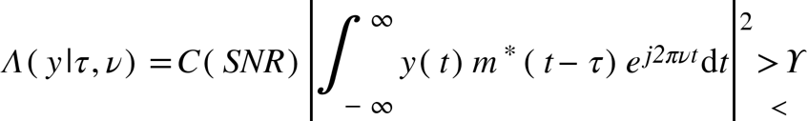

where C is a function of SNR whose exact form depends on the precise nature of the unknown amplitude. When the noise is independent of the unknown parameters, we know from section () the CRLB depends only on the signal portion of the likelihood. Furthermore, since the errors are small we can evaluate at zero mismatch in tau and nu. Thus we may write the information matrix components in () in terms of the AF as

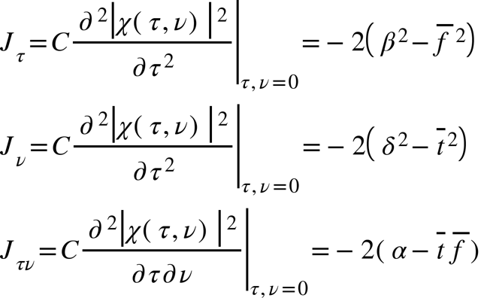

where we have used

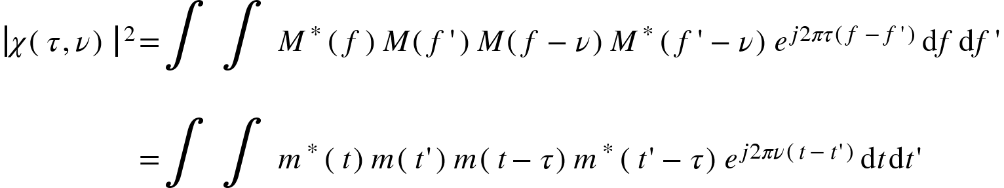

and
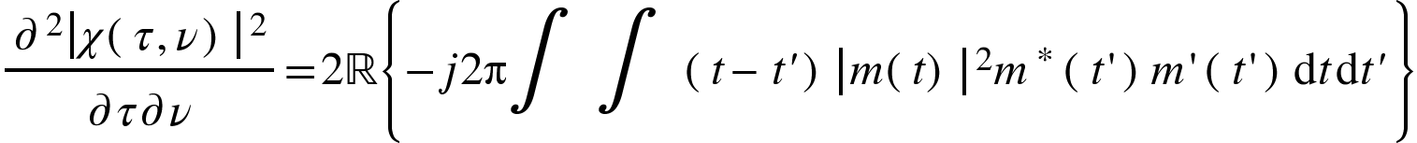

When the carrier and time origin are chosen such that the frequency and time first moments are zero

The information matrix is given by

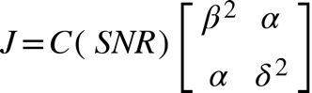

and the variance for any unbiased estimate are therefore

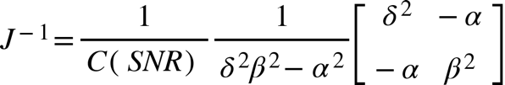

The error bounds for jointly estimating tau and nu are

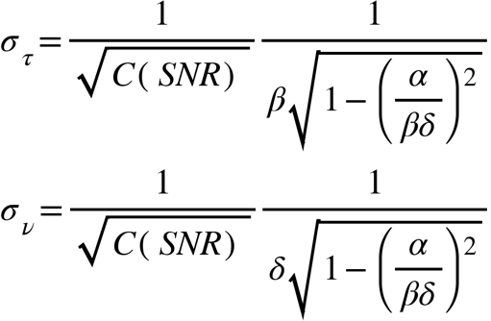

The estimates are uncoupled only when the linear FM constant is zero, or equivalently no phase modulation, in which case they are inversely proportional to SNR^1/2 and either bandwidth or duration, respectively.

Decision Errors for Global Accuracy

Large errors are those that exceed the mainlobe width in time and frequency. The error are analogous to decision error in the case of M-orthogonal signals, with each signal corresponding to the center of a range bin. The matched filter selects the tau and nu coordinates corresponding to the maximum of the LRT over all possible values. An error will occur when the wrong cell is maximum. The issue is complicated if the AF has subsidiary peaks because the signal set is no longer orthogonal. Subsidiary peaks for cell i will interfere with the mainlobe in cell j, for example.

Detection and Performance

This is the active radar/sonar case in which a known signal is transmitted through a channel and its echo is observed. The echo is a distorted version of the transmitted signal that may or may not have intercepted a target. The distortion can take on many forms and we sequentially add complexity by removing the assumptions of what is known about the received waveform and also pass the signal through increasingly difficult channels.

Typically the desired signal is transmitted with an amplitude and phase modulation which are either known or unknown at the receiver. The amplitude modulation contains information about the energy of the signal and its duration T. The phase contains information about the Doppler shift. The standard signal is

For example a(t) can be a rectangular pulse and theta(t) can be an linear FM. Also there
We can assume that all parameters are known and then sample our signal to obtain the signal model

Completely Known Signal

This is the simplest case: all parameters are known and the result is the matched filter.

Consider the active radar/sonar problem in which a baseband signal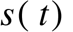of energyis transmitted into a channel with target impulse response 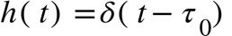. This models the target as a point scatterer at range 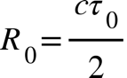where is the two way delay time. After suitably sampling the received signal or projecting it onto some N dimensional signal space we may state the problem as the following hypothesis test

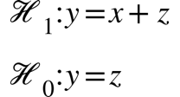

whereis the delayed useful part of the received vector.
In other words the detector is asked to optimally ascertain the presence or absence of a target which is only revealed by the existence of a return echo. We will use the Neyman-Pearson criterion because the apriori probabilities are unknown. Note that we could also state the problem as a parameter test between

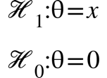

Neglecting constants that may be absorbed into the threshold 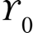, the log likelihood ratio becomes

where we have used . We also define the input SNR

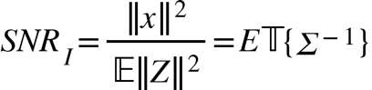
and the output SNR

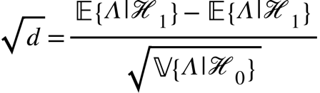

which is commonly referred to as the deflection in the literature. To determine the detector performance we must compute the probability density functions under each hypothesis. To that end let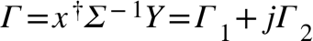which is a linear transformation of Gaussian RV and hence is also Gaussian. Then under H0 we have

Then by the properties of proper complex random variables we know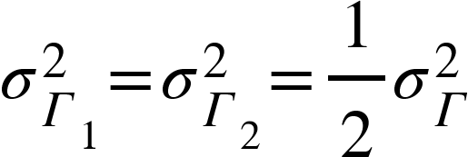, and because ,

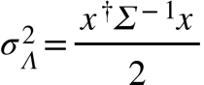

The variances are the same under both hypotheses. The mean of under H1 is computed as

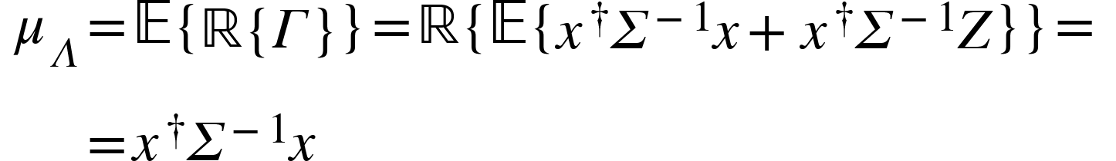

where we have used the fact that is a real scalar. We are then back to the standard mean shifted Gauss-Gauss detection problem encounted in section ().

The deflection is seen to be

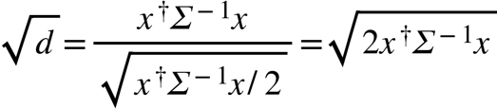

The threshold is determined from the false alarm probability according to

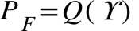

where 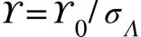is the normalized threshold. The probability of detection is similarly

One can see then that in this simple channel only two factors influence performance: the false alarm rate and the output SNR.

In complex white noise with we may absorb the variance into the threshold immediately which results in the relevant quantities

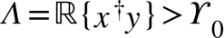
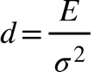
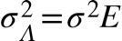
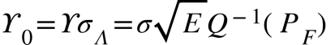
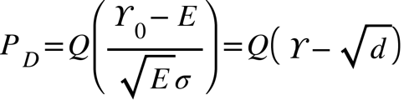

In real white noise the detector becomes

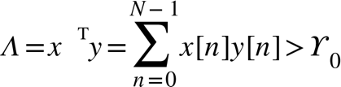

which is a simple correlator (again we have absorbed the variance into the threshold apriori). For the relevant quantities are

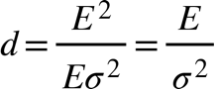
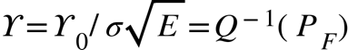

Thus the result is the same as all real RV have the same variance. For simulations it is useful to mandate a unit energy signal and unit variance noise. The result is that the output SNR is the squared amplitude modulation:

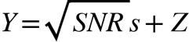

Then thresholds are simply computed by 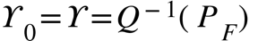and .

In order to gain some intuitive understanding why long data records are important lets us analysze the special case of detecting a real constant in white Gaussian noise. In the real world this corresponds to detecting a known signal with constant amplitude, for example a pulsed sinewave 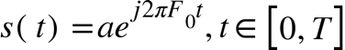, which has been mixed down to DC and sampled to produce a length N signal vector. In this we are observing N noisy measurements of a constant which we write as

where . In vector notation () is equivalent to

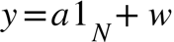

Evaluating the input and output SNRs from () and () we see that

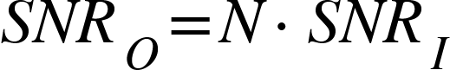

where 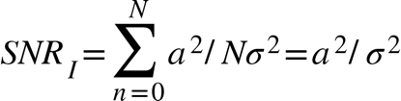is the (“input”) SNR for a single sample, i.e. if the detection experiment was repeated just once. Thus there is a performance benefit directly proportional to the number of samples that we include in our data record. Let us see why. Absorbing the known amplitude into the threshold and then dividing the threshold by a factor N (which will become apparent why) we can write the likelihood ratio as

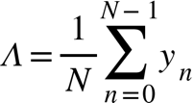

which is recognized as the sample mean. Under H1 this test statistic becomes

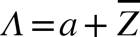
where

is the sample mean of the noise. What we have done is replaced our measurements by a single equivalent sufficient test statistic, indeed the minimum dimensional one, that is now a hypothesis test between a constant and a Gaussian noise RV with variance N times less that the original samples. Intuitively, the noise is evenly distributed about zero so that the sum of its values over time tend to cancel out whereas the signal is constant over time and so tends to constructively, or coherently, add up.

The performance is given by

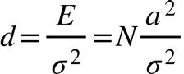
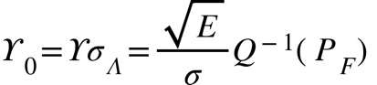

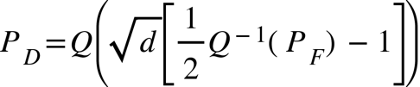

Completely Known Signal in Colored Noise

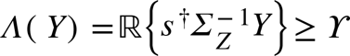

Before taking the real part and defining the complex Gaussian RV 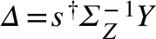, we have

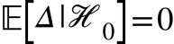

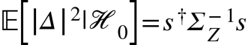

Therefore under H0, . With the signal present

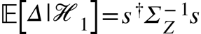
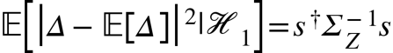
hence under H1 . Taking real part of the test statistic and noting the nonzero mean is real, we obtain a real Gaussian random variable with half the variance, therefore under 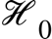 and 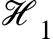, and , respectively.

We note the input SNR is

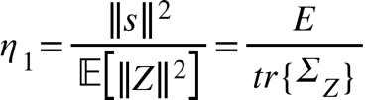

and the SNR at the output of the detector is given by the deflection coefficient

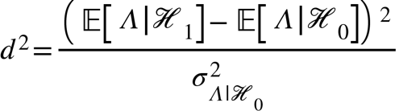

which after plugging in the quantities ()-(), evaluates to

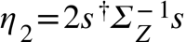

The performance is then given by the standard Q-function for Gaussian RVs

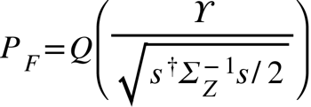

and using

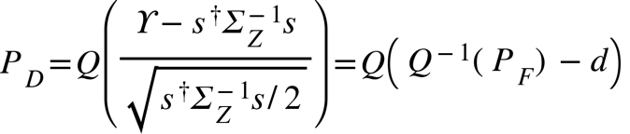

where 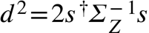 is twice the energy in the whitened signal and the output SNR. If we diagonalize the covariance of the noise as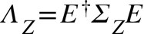 we have

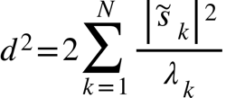

where 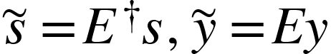. In order to maximize PD we maximize d subject to the constraint 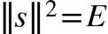we note 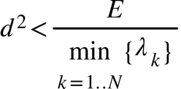. This occurs when sending all power in the eigen-direction corresponding to if 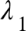is the minimum eigenvalue, i.e. 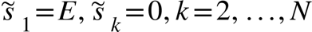. Thus to maximize PD we choose 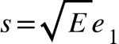.

Detection of Deterministic Signals with Random Parameters
Random signal parameters are treated by in the Bayes’ formulation wherein an apriori pdf is used to compute the optimum LRT. Unknown deterministic parameters are treated by ML estimation and the generalized likelihood ratio test (GLRT).

Unknown Phase

If the receiver does not track the phase of the signal then detection is implemented without knowledge of the phase of the received signal. This is known as incoherent detection. If no apriori information is known about the phase, for example the error pdf of a phased locked loop, it is assumed to be a uniformly distributed random variable and we employ the Baysean approach of section (). The signal model under H1 is

where. Conditioning on the random phase, 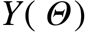is a Gaussian random vector with . The Bayes’ LRT is

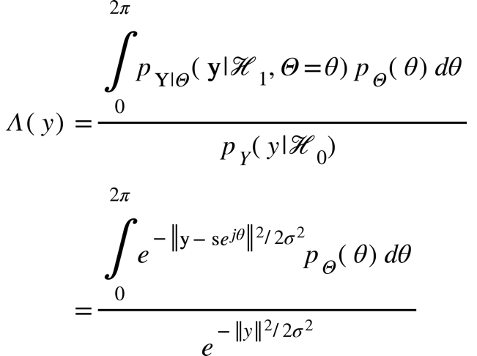

which, after absorbing data and phase independent terms into the threshold becomes

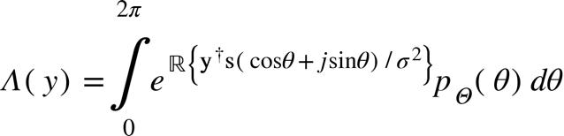

Here we must specify a pdf for the phase. For the special case when 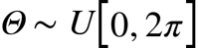, the LRT is

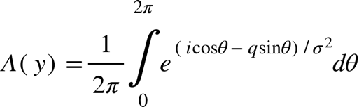

where we have defined the inphase and quadrature phase terms by the relationship

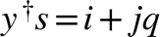

The integral may be put into a tabulated form by changing to polar coordinates via the transformation

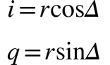
so that

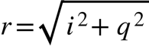

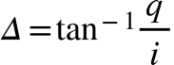

Using the identity we recast () into

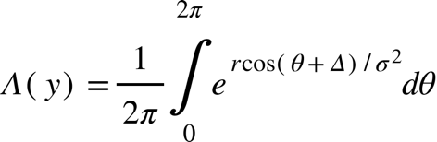

which is 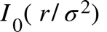. Since this Bessel function is montonic we may use only its argument which we compare to a threshold. Because 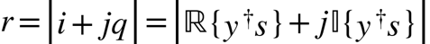 detection rule in terms of the data can be written as

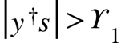

which is known as an envelope detector or quadrature receiver, or alternately as

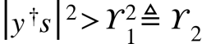

because squaring a number preserves the inequality, which is known as a square law detector.

which shows that the optimum detector is simply the Hermitian product of the complex envelope of the transmitted and received waveforms, and that the presence of amplitude and phase modulation does not present any mathematical complications.

The necessity of the envelope operation may be seen by noting that the matched filter output of a gated sine wave has a maximum at T and multiple decaying peaks. If the phase mismatch is maximum, i.e. 180 degrees, then an exact negative. Since the envelope is independent of the phase, but still decays from max value, and envelope detector avoids

Performance

Performance is analyzed by computing the pdf’s under each hypthesis. Using the quadrature detector we use a Ricean density under H1, and using the square law detector we use a noncentral Chi-square. Both analyses yield expressions for PD and PF which can be used to generate ROC curves. Because many other detectors involving unknown signal and noise parameters result in Chi-square densities, let us use the square law detector.

Under H1, , therefore conditioning on the random phase, it is a complex Gaussian RV 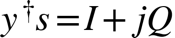with mean 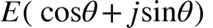and variance . Equivalently in terms of its real and imaginary parts which are conditionally Gaussian RVs we may write the test statistic () as

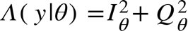

which is has Chi-square density with two degrees of freedom and noncentrality parameter , or

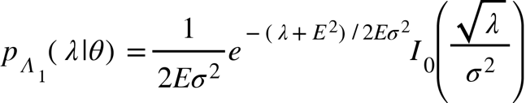

Since the pdf does not depend on , we may integrate it out. Next, in order to parameterize this function in terms of the output SNR for coherent detection,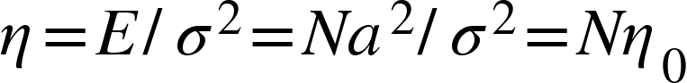, change variables and 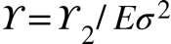. The threshold 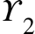 should be used for simulating the probability of detection by comparing the squared envelope in (), whereasshould be used as argument to tabulated Chi-square functions from a numerical suite such as Matlab when computing the performance analytically. For simulations it is useful to choose a unit energy signal and unit real variance therefore only a single parameter is needed. The signal model can be written as 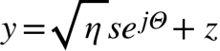where 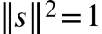and . Proceeding with the normalization we have,

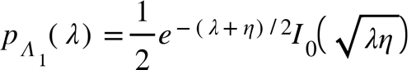

which is a normalized noncentral Chi-square density with two degrees of freedom and noncentrality parameter, 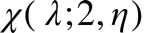.

The H0 pdf is found by setting 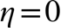resulting in (a Chi-square density with two degrees of freedom)

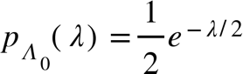

The SNR at the output of the detector using the normalized pdfs is

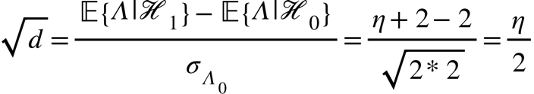

we see that the output SNR is a factor of 2 less than for coherent detection. Thus accounting for the random phase results in a 3dB loss in output SNR.

The threshold is then found by solving

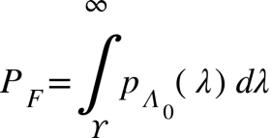

which results in choosing a threshold such that 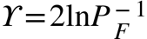, or

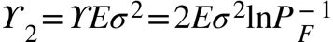

The probability of detection is

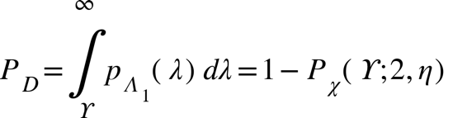

If a envelope detector is used, the resulting pdfs may be obtained by letting 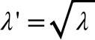and 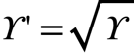in the above, which results in a Rician distribution

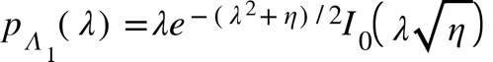

under H1 and the Rayleigh distribution

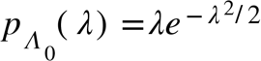

under H0. In this formulation the probability of detection is given

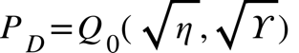

where

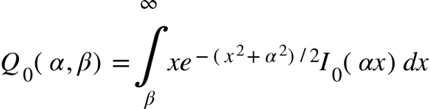

is Marcum’s zeroth order Q-function

For a mismatched detector wherein a random phased sinewave the PDF under H1 is

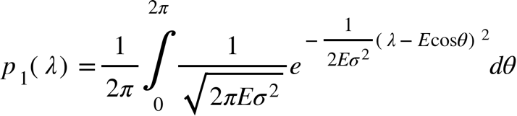

which does not have a closed form.

Figure () shows that the resulting decrease in performance is only about 1 dB over most SNR values.

To see why this is so consider Fig () which represents the vector spaces (lines) of the signal vector, signal s vector with random phase x, noise vector g, and received vector,y. The test statistic is the magnitude of the projection in the direction of the signal. Under coherent detection the problem is one dimensional where a large negative noise value can cause 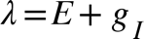, where 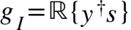, to be smaller than the threshold in which case an error has occurred under H1, i.e. a miss. For the noncoherent case we are concerned with the projection of the vector sum 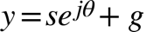onto . Hence, two independt noise vectors contribute to the net projection. In this case one or both of the noise vectors must be large and negative which does not occur that often. Therefore there is not much difference in performance. At very high SNR the effects of noise are minimal, hence performance at high SNR is similar.

coherent
incoherent

However, because the output SNR is 3 dB less this must be taken into consideration when determining the required output SNR to achieve a given PD. In other words Fig () gives the required value of 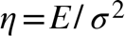to achieve a given PD for a specified PF. The required output SNR for a given PF, PD will 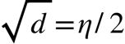. One could also parameterize the pdfs in terms of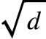instead.

Detection of Multiple Incoherent Pulses

Unknown Amplitude

In the signal absent/present hypothesis test we have

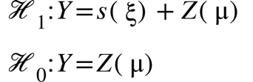

where and are an unknown random or deterministic parameters of the signal and noise respectively. For example, may be an unknown uniformly distributed random phase, and amplitude or a delay, and may be an unknown mean, variance, or covariance matrix. Eqn gives rise to the GLRT

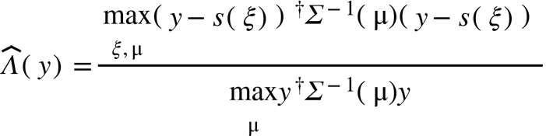

where the hat distinguishes between the Baysean and ML liklihoods.

1) ML estimate of covariance matrix for Gaussian distributed prior.

Suppose we receive K i.i.d zero mean complex Gaussian random vectors and wish to estimate the covariance matrix based on the observed values Xi. The density function conditioned on is

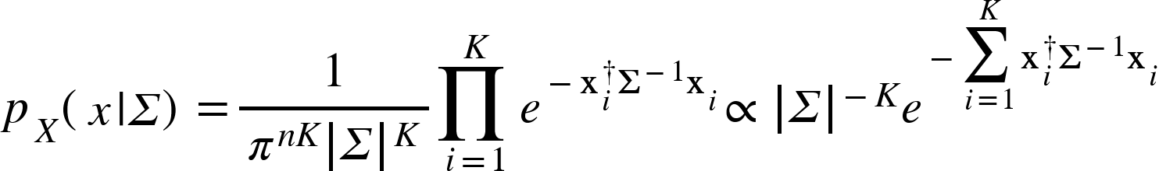
applying the identity 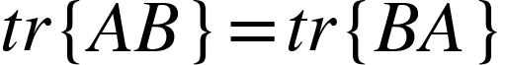to the scalar exponenent, defining the so called scatter matrix,
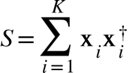

and then taking logarithm yields the objective function

.

Assuming the Xi are all LI, and then employing the spectral decomposition to the matrix defined by and using the properties of the determinant

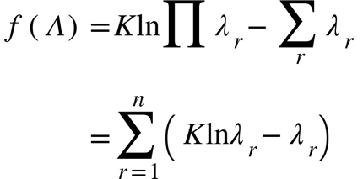

differentiating wrt lambdar and setting the result equal to zero reduces the problem to the set of n 1 D maximizatinon problems with solution

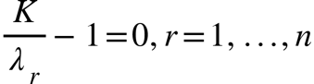
or Therefore from definition of M,

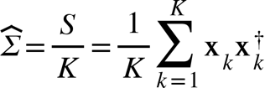

which differs from the sample variance by the scale factor K instead of K-1. If there is a deterministic signal component then we write the ML covariance estimate under H1 as

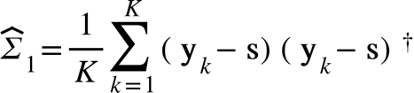
and under H0

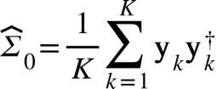

If the unknown signal parameter is amplitude the ML estimate based on the likelihood ratio

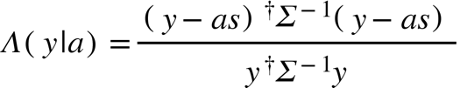
Differentiating wrt a (and being careful to observe the rules for complex differentiation) we have

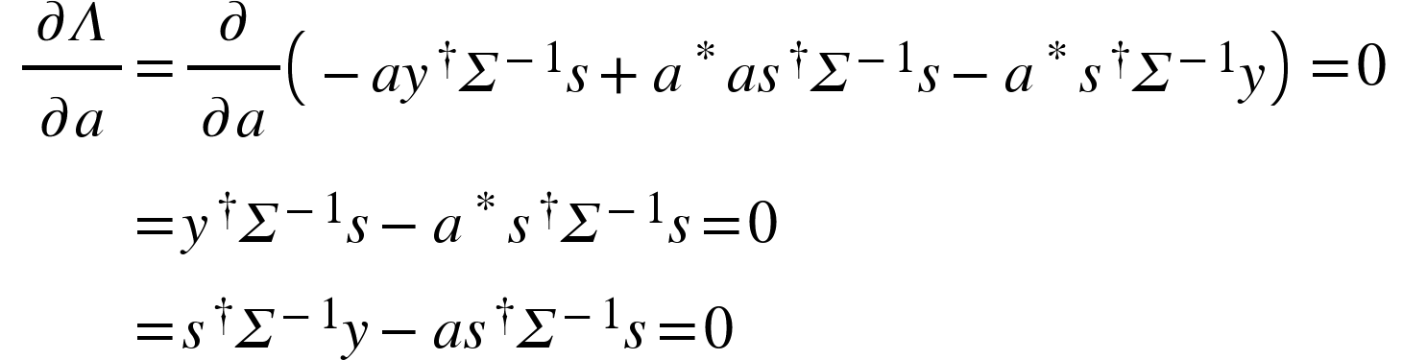

where we have Hermitian each side and used the fact that a symmetric quadratic form is a real number, leads to the ML amplitude estimate

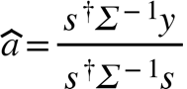

Note that is a complex number and thus accounts for a phase rotation and a real amplitude coefficient. Substituting this expression and the ML covariance estimate into the GLRT, cancelling terms and absorbing the factor 1 that results into the threshold, results in the test statistic

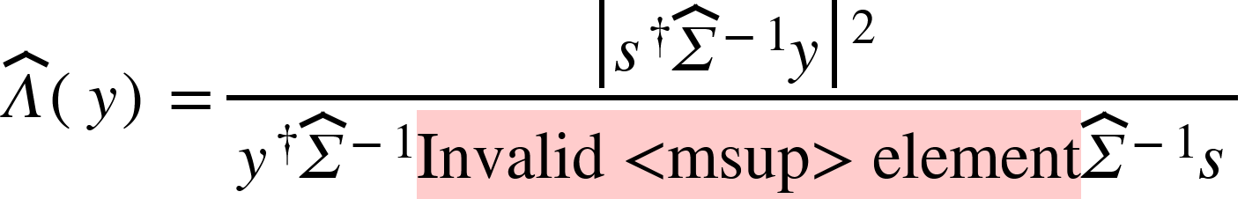

The detector has the constant false alarm property (CFAR) which means the H0 density is independent of the covariance matrix.

In the specialization to white noise with (unknown) variance and a signal with energy 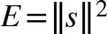(absorbed into the threshold), the test statistic becomes

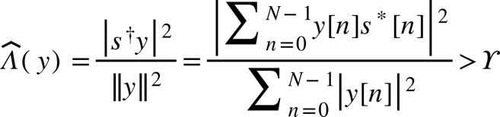

which is compared to a threshold . In this example the signal is assumed to be matched in delay, Doppler, and beam space so that we may neglect any mismatch to the replica.

Under H1, noting that 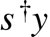is complex Gaussian with mean and variance , the numerator is the sum of squares of and which leads to the noncentral Chi-square density with two degrees of freedom and shape parameter . The denominator is the sum of the squares of N , or N and N , which leads to the noncentral Chi-square density with 2N degrees of freedom and shape parameter 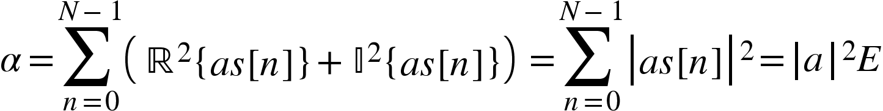

Unknown Amplitude
Consider a signal model where the channel imparts a random gain, which we model as, where 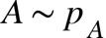and is a uniformly distributed random phase, to a known transmitted signal, . As such the receiver is assumed to have knowledge of neither the phase nor the amplitude.

Conditioned on the unknown quantities, the likelihood function of the observations becomes

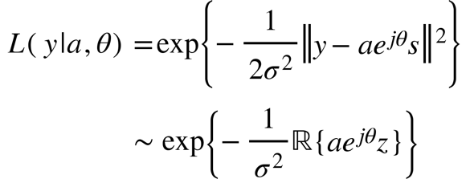

where the matched filter output is define as
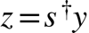

Averaging with respect to the unknown phase we arrive at the test statistic

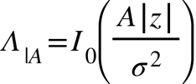
Since I0 is a monotone increasing function, the average of () wrt A is also monotonic in the argument of I0 regardless of the distribution of A. Therefore the optimum NP detector compartes the test statistic to a threshold. However, the performance will of course depend on the distribution of A.

Unknown Time Delay

In white noise, completely known signal except for delay , such that the signal mean at time n is 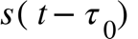

Must ensure that signal is completely within the observation time, also the signal epoch is known, so that 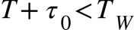. In discrete time we have. In converting to discrete time we have implicitly assumed a white noise process with bandwidth and spectral level 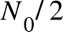which when sampled at the Nyquest rate yields iid Gaussian samples. The data model is

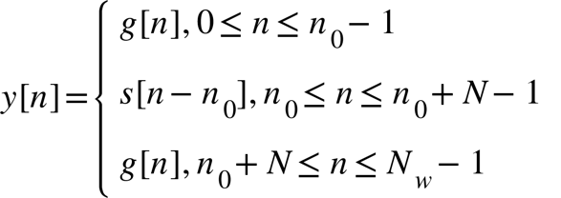

or as an Nw vector 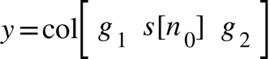. The pdf under H1 with n0 as a parameter is . Although in continuous time the signal delay is acontinuous-valued variable, in discrete time it is not.Consequently, the maximum likelihood estimatecannot be found by differentiation, and wemust determine the maximum likelihood estimate of signal delayby the most fundamental expression of the maximizationprocedure.The MLE is determined by maximizing the logarithm of this pdf wrt n0 which enters only through the signal term and thus we may discard the data outside the signal interval which results in the estimate

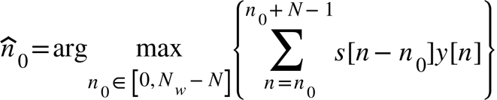

where we have ignored the terms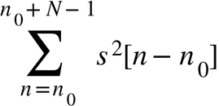which is simply the energy of the signal and 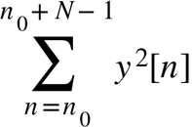 both of which are independent of n0. This operation forms all possible correlations over the signal interval contained in the data window and selects the value of n0 that achieves the maximum as an estimate of the delay. The estimate is unbiased because the maximum of the expected value of () is the signal energy which occurs at the actual delay. The GLRT is formed by substituting the MLE into the LRT to yield the decision rule

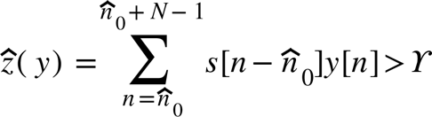

Owing to the similarity with () we can write () as

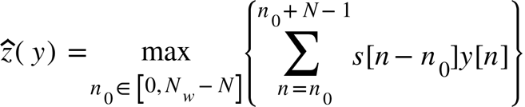

which is a search over all possible shifted signal replicas contained in the window. The degree of accuracy of the delay estimation will depend on the signal auto correlation function, or equivalently its bandwidth.

In addition to the complexity of finding the maximum likelihood estimate, the discrete-valued nature of the parameter also callsinto question the use of the Cramér-Rao bound. One ofthe fundamental assumptions of the bound's derivation is thedifferentiability of the likelihood function with respect to theparameter. Mathematically, a sequence cannot be differentiatedwith respect to the integers. A sequence can be differentiatedwith respect to its argument if we consider the variable to becontinuous valued. This approximation can be used only if thesampling interval, unity for the integers, is dense with respecto variations of the sequence. This condition means that thesignal must be oversampled to apply the Cramér-Rao boundin a meaningful way. From 15-() the CRLB for the continuous delayis

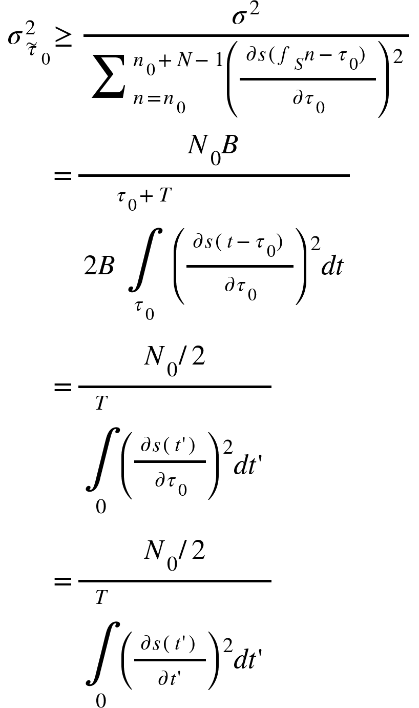

where we have used the chain rule

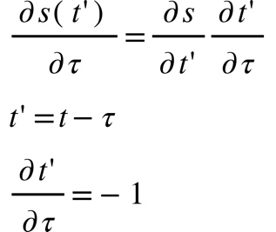

Using Parseval’s Identity for the function 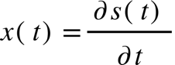, we switch to the frequency domain
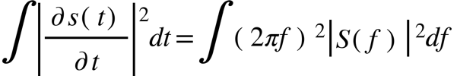

Defing the root mean square bandwidth as

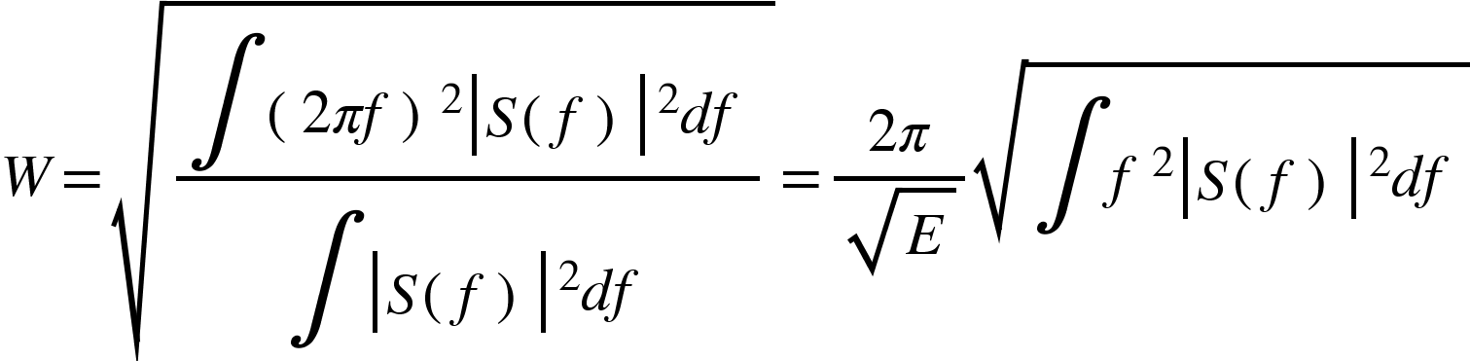

which is seen to be the normalized square root of second spectral moment about f=0 with units of Hertz, results in the bound

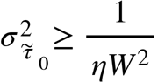

where 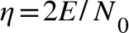is the input SNR to the matched filter. The range error is

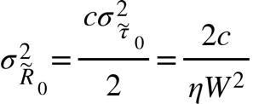

Unknown Noise Parameters

Subspace Signals

Often the signals of interest can be described as belonging to a low dimensional vector subspace. Thus the linear structure of the signal is exploited to improve detection. If the subspace is known aprior then only the modes weights need be estimated. Often the entire subspace is unknown and then it too must be estimated.

Detection of Stochastic Signals

Spectral Detection

by the now familiar double symmetric sum formula.

From section () we know that if the observation time is chose to be large compared to the inverse noise bandwidth, then in the Fourier domain, the resulting noise coefficients are approximately uncorrelated. Thus, in the frequency domain the colored noise problem can be converted into a white noise problem. If in addition the PSD of the processIf the correlation structure is much less than the observation time. Define the FT of the signal at frequency k as 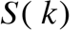 and the noise spectral covariance matrix is identity. Then for a known deterministic signal we simply compute the complex correlation and take the real part

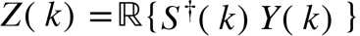
The frequency of the signal equals one of the analysis frequencies, 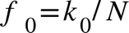, then all other coefficients are zero and we may replace () by

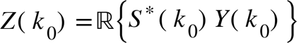

Signal Parameter Estimation

Spectral Estimation

Signal Design

Signal design refers to choosing the parameters of a transmitted waveform, i.e. duration, bandwidth, shape, etc, to achieve the desired system performance, i.e. range/Doppler resolution, clutter rejection, maximum range, etc.

We begin with the narrowband signal model for a baseband complex transmitted waveform , received in AWGN after impinging on a target which produces an unknown round trip delay time 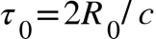and unknown Doppler shift 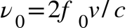in the received signal

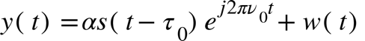

where is an unknown deterministic (or random) complex amplitude which accounts for the unknown received signal level and phase. The ML detector for this signal model is the normed correlator

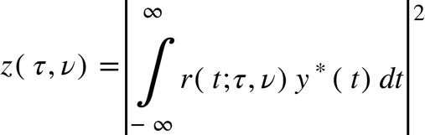

with replica

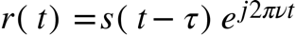

whose output is maximized over all possible delays and Doppler shifts with the resulting maximum values 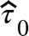and 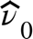serving as estimates of the delay and Doppler, respectively. Expanding out yields

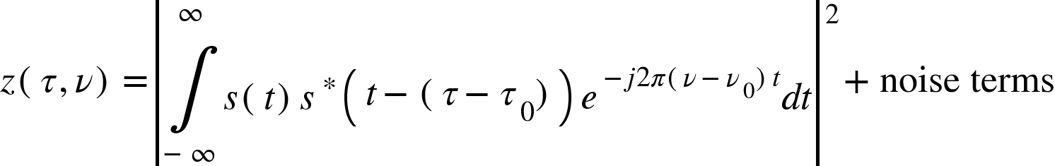

which we may cast in terms of the central ambiguity function defined as

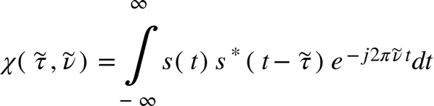

where 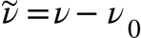and 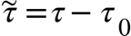are the mismatch displacements in Doppler and delay, respectively. Note that () is the magnitude squared of the Fourier transform of the shifted waveform product wrt to Doppler shift, i.e. the frequency domain representation is

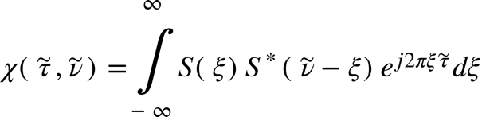

It is essentially a correlation performed in both time and frequency. The ambiguity function is centered at the origin, i.e. zero mismatch between actual delay and Doppler values and the search space variables. The level curves of the ambiguity function, known as ambiguity diagrams, determine a region of uncertainty about the actual values of delay and Doppler for a specified mismatch. It defines a two dimensional region in the the delay-Doppler plane as illustrated in Figure () corresponding to a particular value below the maximum value of 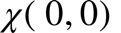, for example the half power level. Thus the origin is the point in the delay –Doppler plane corresponding to no estimation error. The decay of the function in two-space determines the loss in the matched filter output caused by mismatch in the replica or error due to additive noise. The noise terms can shift this maximum erroneously and thus cause errors in the parameter estimates. However, only noise values of sufficient power to shift the maximum outside the ambiguity region contribute to an error.
actual target location
Because any noise will superpose with the signal term at the output of the detection, given by the ambiguity function, the ideal ambiguity function would be one which was concentrated at a single point and zero elsewhere, i.e. a delta function. But of course this function is not realizeable because it must have an infinite duration in both time and frequency which is impossible.

From Figure () one can see that if the noise is sufficient to maneuver the maximum value from the origin to some other point in the delay-Doppler plane an error will be made at the output of the ML detector. Therefore,the ideal signal would be one which minimizes the potential for noise to shift the nominal maximum value. This occurs for a signal with an ambiguity function that has zero amplitude everywhere except at the origin.

The next important value of the ambiguity function is that it allows one to determine the global accuracy of an estimate. This analysis corresponds to the situation where we want to determine if the range Doppler estimate occurs in the correct cell. A cell divides the range Doppler plane into rectangles whose widths are proportional to the dimenstions of the central peak of signal ambiguity function.

Detection In Reverberation

Here we complicate the active sonar/radar problem of detecting a slowly function target by augmenting the signal model to include a structured noise term in addition to the standard white Gaussian noise. This new term is structured in the sense that it can well defined enough by an appropriate model, either a deterministic one, such as a coherent multipath environment, or a colored Gaussian noise with known or estimable covariance function. This noise is termed clutter/reverberation/interference. Interference will be taken to mean a coherent term such as multipath or coherent scattering. Reverberation is the result of the transmitted signal propagating through the channel and encountering distributed scatters such as volume, bottom, surface scatterering inhomogieties. Clutter is radar nomenclature for sonar reverberation. These scatterers cause unwanted reflections which superpose with the desired target signal. The task of the receiver is to optimally distinguish between the wanted and unwanted portion of the signal, i.e. target and white noise plus reverberation. We formulate the problem in continuous time for theoretical simplicity, and then develop a vector model for implemenations subsequently. One might surmise that because the reverberation term is a result of the intial active sonar pulse the detector will depend on knowledge of the correlation between the signal and the channel response filter.

The detector must perform the following hypothesis test for the presence or absence of target signal x(t)

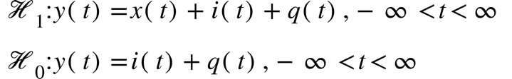

distributed interference
Doppler discriminable target
Doppler nondiscrimable target
where x is the target signal described by the target impulse response

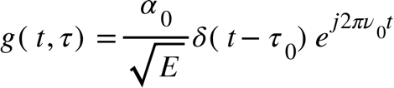

where 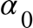is an unknown complex constant which has been normalized by the signal energy, is the target location interms of its two way delay,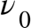is the Doppler shift caused by relative radial motion between the target and receiver, and I and q are uncorrelated.. Note that we have not included any time or frequency distortion, or an multipath off the target. We are operating in the narrowband regime where the only distortion is in amplitude, phase, delay and Doppler. The received target signal is then

where E is the transmitted signal energy and s(t) is the unit energy waveform. The reverberation is characterized by its time varying impulse response 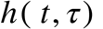which specifies the channel response at time t to an impulse at time . The impulse response is characterized either by its ensemble or time average correlation over time and delay

where we have assumed the correlation depends only on a single variable , i.e. only on the relative time shift. For a stochastic impulse response this is equivalent to a statement of WSS, and for a deterministic model it means correlations in time need only account for a relative offset. We may approximate such a function by a two dimensional average over a time interval for fixed delay as

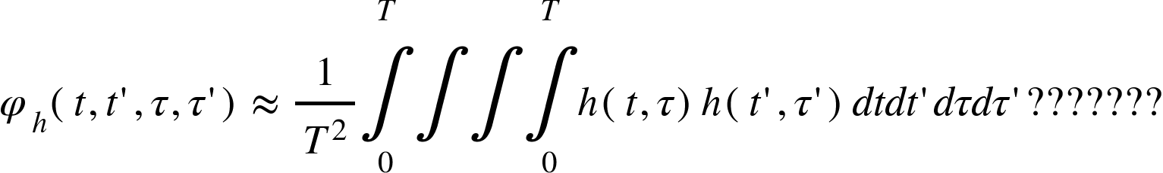

The impulse response correlation function can also be represented in the range Doppler plane by FT wrt to time difference,

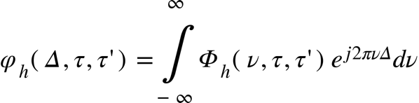

where 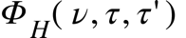 is the scattering function.

The impulse response can be either deterministic or random, in which case time averages are used to approximate ensemble averages. The interference term is then

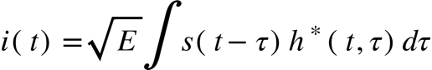

The time correlation function of the interference is

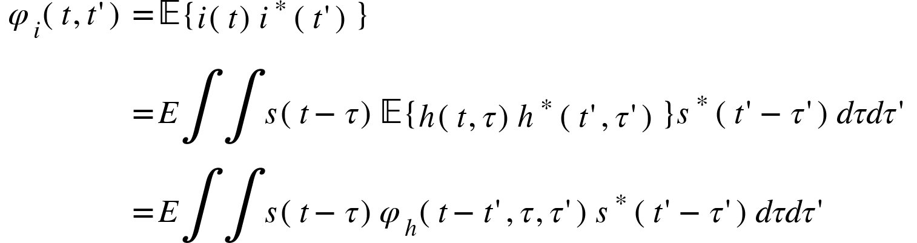

The inner correlation is a measure of the time variability of the channel which is then used to weight the signal correlation between two different delays and two different times.

Let us now compute the output SINR for the conventional detector as a function of delay and Doppler, i.e. the normed ML correlator,

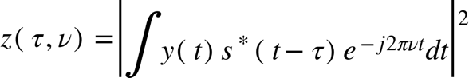

Define the SINR to be

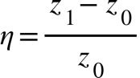

where .
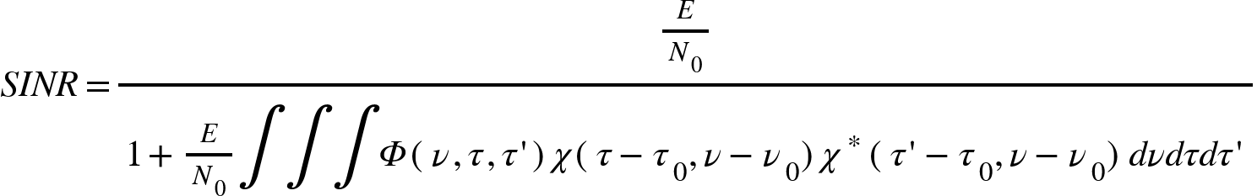

Performance depends on the overlap between the reverbatin scattering function and the uncertainty functions at different delay times. The correlation between the two uncertainty functions is weighted by the scattering function amplitude corresponding to the particular two delay values.

The above development can also be converted to a discrete forumulation in the cardinal variable for time and frequency, and . This leads to a vector model which we now develop.

Sonar/Radar Equation

The input SNR to the signal processor for the model

is
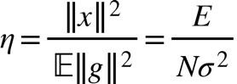

which for a constant amplitude received signal and complex white noise is 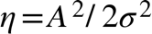. The output SNR is given by the deflection

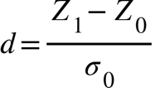
where

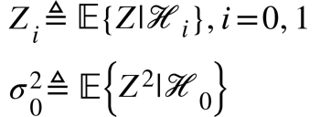

For an squared envelope detector () evaluates to 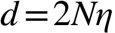, where the factor of two is a scale factor reflecting the two dimensions of the complex domain. Given a prespecified PF and PD, a value of d is determined from the underlying distributions of the test statistic. This value determines the minimum output SNR required to achieve the desired performance. If we interpret E to be the received energy level of the signal including all channel effects, i.e. transmission loss, target interaction, which alters the intial signal energy 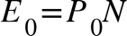, where P0 = E0/N0=E0/(T0*fs) is the average power or intensity.

The average intensity (power per unit area) over an interval T is

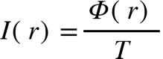

where 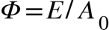 is related to the squared pressure amplitude (energy) per unit area of the propagating plane wave at distance r.

For a generic bistatic sonar situation there are three interactions we must consider: source to target, target reflection, and target to receiver. The latter two involve spreading loss and the target interaction involves the ratio of incident intensity to reflected intensity. Let us take each in stride and formulate and equation for each leg and then combine them at the end to produce a relationship between the energy generated by the transducer, E0, and the energy received at the receiver, E.

For source to target we have by conservation of energy (energy per time per area at distance 1 must be equal to energy per time per area at distance two assuming a lossless medium)

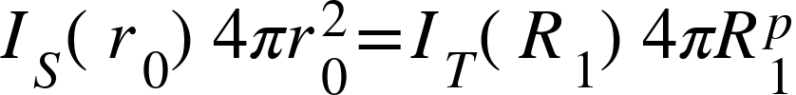

where p is the spreading factor and r0 is a reference distance from the source. At r0 from the target the reflected power satisfies

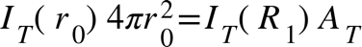

where AT is the intercepted cross sectional area of the target. Lastly, the power conveyed to the receiver at R2 from the target source at r0 satisfies

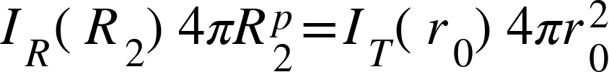

Combining ()-()

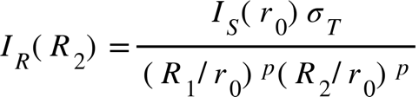

where the target cross sectional strength is defined as

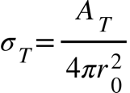

Note that all quantities are defined with respect to a reference level r0 which we take as 1 meter so that all units are MKS, i.e. physical units such as meters, watts, etc. For target strength this value is arbitrarily positive or negative depending on the chosen reference level, i.e. a positive value does not mean more energy was reflected than incident. For a sphere of radius a 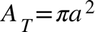and r0=1 m, the TS is

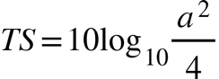

which is positive for a>2 meters. If a submarine is approximated as a sphere of radius 50 meters the TS is . In terms of average energy per T seconds wrt to 1 meter reference

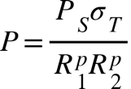

which is the desired expression relating source energy to received energy. Defining the detection threshold as

because the noise spectral level per Hertz is ,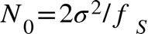and 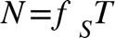. () determines the minium output SNR in dB to achieve the desired Pd and PF. Because () is in terms of ratios, i.e. unitless quantities, we may take logarithms

substituting () into () yields

Defining
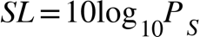
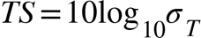
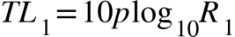
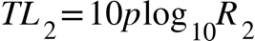
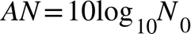

we arrive at the bistatic sonar/radar equation for white isotropic noise

which when satisfied with equality gives the correct output SNR to achieve the desired PD and PF and incorporates the effects of the source, target, channel, and noise.

Doppler Shift

If the source is stationary and the receiver is moving relative to the source with radial velocity , the Doppler shift at the receiver is

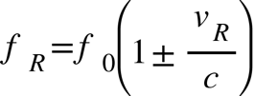

where the sign convention is chosen such that positive sign is taken when the receiver is moving towards the source. In reality is depending on the angle between the source and receiver, and when explicitly included will account for the sign. If the R is closing, then the Doppler shift is up, i.e. positive sign, and vice versa for receding. If the source is moving with radial velocity 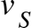 and the receiver is stationary the Doppler shift is

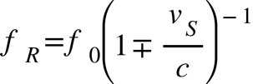

Here, if the source is closing the negative sign is chosen to reflect the up Doppler. When both S and R are moving, the nominal source frequency becomes

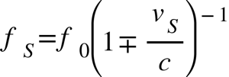
and the received frequency is then

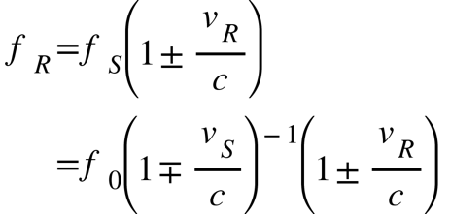
Using the binomial expansion and neglecting product terms,

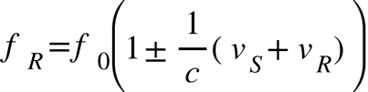

Next consider a monostatic situation with a moving target and a collocated source and receiver as in Figure ().

The source emits a tone at frequency 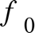, which when it reaches the moving target has changed to frequency 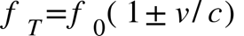 owing to the target’s motion. The target then reradiates the impinging acoustic energy field according to its scattering response function as a moving source. The source the receives a frequency 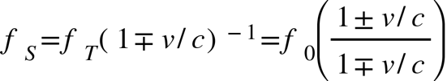. Using the bionmial expansion on the denominator yields the value of for the Doppler shift. The Doppler shift is proportional to to the ratio of the speeds of the target and sound. What this means is that for tone like waveforms, i.e. narrowband signals, the effect of target motion is simply to shift the signal spectrum by a fixed value, the Doppler shift. Thus the spectral template provided by the matched filter need only be shifted accordingly to regain its optimal properties.

For a bistatic situation in which a target moves in the field of a spatially separated source and receiver, the Doppler shift depends on the geometry illustrated in Figure ().
Two sets of Doppler shifts occur as a result of bistatic motion. Note that his formulation is only appropriate for a monochromatic sinewave. For more general waveforms an explicit compression/dialation of the time axis occurs which gives rise to the distinction between narrowband and wideband waveforms based on their time-bandwidth product relative to the ratio of the radial velocity to the speed of the wave. The motion between the source and target creates the first Doppler leg (where the source is the source and the target is the receiver). This Doppler shifted frequency becomes the source for the source to receiver leg (the target is the source and the receiver is the receiver). Combing yields,

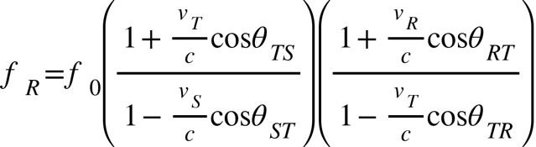

If the source and receiver are stationary and we employ a series expansion, the received Doppler shift simplifies to

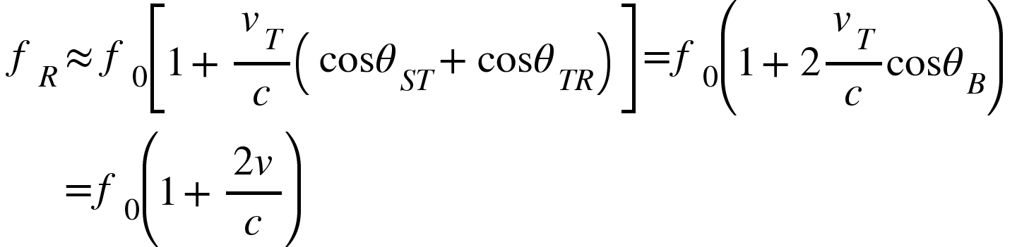

which is the standard result for narrowband Doppler shift, and where we have lumped the angular dependence into the bistatic radial velocity term denoted simply by . Thus the Doppler shift involves only the radial component of velocity. Defining the speed ratio

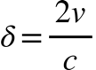

and the Doppler shift

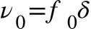

we write

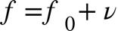

The radial velocity is the rate of change of the radial position, i.e. 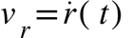which is

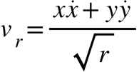

Thus for targets at long range the radial velocity is small, all the velocity is contained in the tangential component which is not reflected in the Doppler measurement. For a CW pulse the finite epoch causes Doppler broadening so that it is not a pure tone. However, if the transmit frequency is large compared to mainlobe of the sinc (window) function, i.e.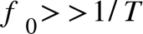, then the narrowband assumption holds and Doppler shift is given to a good approximation by ().
For specular incidence , from Fig () we see 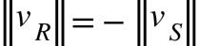hence the Doppler shift from ST exactly cancels that of TR. For 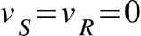, , and using binomial expansion,

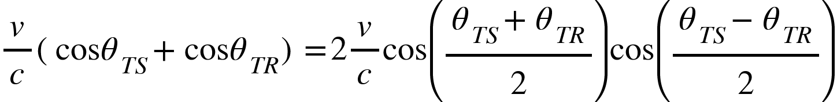

from TR. Thus there is no target induced Doppler observed at the receiver for specular reflection. The particular geometry resulting from the specular condition creates a symmetry which causes the velocity along the radial line connecting S and T and T and S to exactly cancel. For any other angle these components are not equal and opposite and a Doppler shift is observed.

Specular condition is

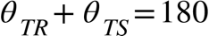

at specular equals zero.

Let the transmitted signal be of the form

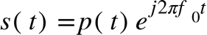

where p(t) is a unit energy complex envelope with support in 0 to T, f0 is the carrier frequency. Retaining only the up to the linear coefficient in the series expansion for delay, the received signal 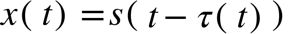 may be written after some algebra as

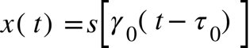

where the time compression/dialation factor is

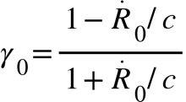

The expression () leads to the most general form of the ambiguity function. A number of specializations may be made.

For velocities of interest

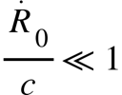
thus

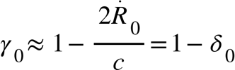
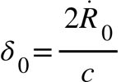

The received signal may then be written as

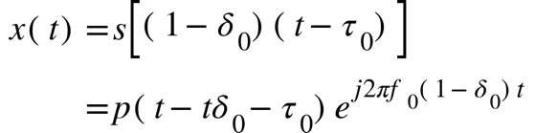

where we have assumed 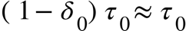and disregard ed the carrier phase term 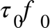which can be absorbed into the constant phase term. It can be seen from () that there are two effects:

1) a stretching or compression of the time axis of the complex envelope
2) a frequency shift of the carrier frequence equal to 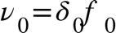.

The first effect may be ignored if the waveform does not change appreciably over the maximum deviation time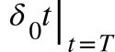, i.e. when the difference in the argument is maximum the the maximum difference in amplitude of p(t-dt) will occur. Since a waveform does not change significantly on the order of its inverse bandwidth , the condition for ignoring the time scaling becomes

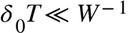

or in terms of the time bandwidth product

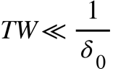

Under this assumption the baseband received signal can be written in terms of two parameters, a time delayed Doppler shifted baseband signal,

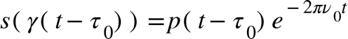

For sonar applications in which c = 1500 m/s and v = 15 m/s, 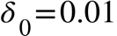, therefore TW must be smaller than 100. For avionic channels using radar, c = 3x10^8 m/s, v = 500 m/s, so that TW<6000.

